|  |
| --- |
|  |
|  |
| **RDP Client Endpoint Test Suite**  **Lab Tutorial**, **v4.0**  March 20, 2023 |
|  |
| Abstract  Training in RDP Test Suite Technology |
|  |
| Author Microsoft ADC Protocols Test Team  **Greg Gille** | Microsoft Content Development PM Engineering  GRC Protocols Content Team |

**Table of Contents**

Introduction 4

Test Suite Training Audience 4

Training Environment 4

Goals of the Test Suite Training 5

Glossary Definitions 6

Concepts 9

What You Will Learn 9

Protocol Communications 9

Test Environment Architecture 11

Configuring the RDP Client Test Suite 14

Configure the RDP Client Test Suite Using the PTM Service 16

Selecting Test Cases 25

Creating Test Case Configurations 25

Creating the Lab Session Test Configuration 28

Configure the Test Suite by Loading a Profile 32

Running the Test Cases : Options 35

Monitoring Test Case Execution Results Indicators 36

Using the PTM Service to Execute the Test Cases 37

Creating a Profile 38

Working with Playlists 40

Using a Command Line Tool to Execute Test Cases 41

Analyzing the Test Results Data 43

Test Results Output and Status Indicators 44

Low-Level Status Indicator Meanings 47

Common Failures 47

More Information 48

Resources 48

**Table of Figures**

Figure 1. Partial RDP connection sequence : Example 10

Figure 2. RDP Client Test Suite: Network Domain test environment 12

Figure 3. Test Environment : Test Cases communication path 13

Figure 4. RDP Client Test Suite: PTM Service landing page 14

Figure 5. PTM Service: Tasks list and configuration space 14

Figure 6. PTM Service : Select the RDPClient Test – (4.23.3.0) suite task 17

Figure 7. PTM Service : Test Suite Introduction task : RDP family of protocols 18

Figure 8. PTM Service : Select Configuration task space 19

Figure 9. PTM Service : New Test Suite Configuration dialog 19

Figure 10. PTM Service : Configure Method task 20

Figure 11. PTM Service : Auto-Detection task configuration 21

Figure 12. PTM Service : Detection Results 23

Figure 13. PTM Service : Filter Test Cases configuration task 24

Figure 14. PTM Service : RDP Protocols, Test Cases, and Feature correlations 26

Figure 15. PTM Service : Tutorial Session Test Case and Feature configuration 29

Figure 16. PTM Service : Reviewing/optionally configuring Test Case properties 29

Figure 17. PTM Service : Control Adapter settings 31

Figure 18. PTM Service : Test Case Execution Configuration 32

Figure 19. PTM Service : Loading an existing Profile 33

Figure 20. PTM Service : Running the Test Cases 35

Figure 21. PTM Service : Test Case execution status monitoring 36

Figure 22. PTM Service : Selecting and executing Test Cases 38

Figure 23. PTM Service : Creating and Saving a Profile 40

Figure 24. PTM Service : Saving a Test Case configuration as a Profile 40

Figure 25. PTM Service : Creating and saving a Playlist 41

# Introduction

This Tutorial provides step-by-step instructions for connecting to and configuring the **RDP Client Endpoint Test Suite (RDPCETS)**, in preparation for executing predefined **Remote Desktop Protocol (RDP)****Test Cases**. These Test Cases exercise various functions of specific RDP protocols in Remote Desktop scenarios. Following test execution, you will perform some basic analysis of test results. You will also be provided with the necessary test environment assets that facilitate the configuration and execution of tests in a virtual session.

Although you can manually configure the test environment, execute Test Caseswith scripts (.ps1,.sh), and review test results analysis from the command console, this Tutorial focuses on using a built-in tool known as the **Protocol Test Manager Web Service**,herein after referred to as the **PTM Service**. This tool enables you to perform these tasks and summarize results while making use of automation to simplify configurations and improve efficiencies in the tasks you will be performing.

The **PTM** **Service** and the **RDPCETS** are already installed on a **Driver computer** **VM** where you will conduct the testing, and to which you will have access to the test environment via an IP address that you launch in a web browser (or with a **Remote Desktop Services (RDS)** connection).

The audience for this Tutorial/Lab session is described just ahead, as are the goals of this Training and the details of session organization.

Note



The **RDPCETS** may also be referred to in this Tutorial as the **RDP Client Test Suite** or simply the **Test Suite**.

## Test Suite Training Audience

The primary audience for the **RDP Client Test Suite** training is software developers who have little or no experience with running protocol Test Suites, RDP protocol support personnel, and even those who already have significant experience with RDP technologies. Each can benefit from taking this course.

Other audiences can include IT professionals and others who may be interested in learning about protocol Test Suites.

## Training Environment

This Tutorial is intended for use in an RDP IO Lab session during a Microsoft-hosted Event with support and instructional personnel on hand for assistance. However, this RDP IO Lab session Tutorial is also publicly available to anyone who wishes to use it for testing RDP implementations outside of the Microsoft RDP Lab Event environment. For this reason, the Tutorial will also continue to be available to event attendees who want to further sharpen their skills with RDP testing technologies following their initial training session at a related Microsoft RDP event.

It is with this in mind that the document was written to be a stand alone volume that you can consult at any time, with the content of such quality that it should enable you to walk through any testing scenario you might be required to perform on your own.

To use the RDP Client Test Suite Lab Tutorialas a guide for RDP testing outside a Microsoft event, you will need access to a working RDP Client Test Suite installation; either an already existing installation, or one that you can install and set up yourself, as specified in the [**RDP Client Test Suite User Guide**](https://github.com/microsoft/WindowsProtocolTestSuites/blob/main/TestSuites/RDP/Client/docs/RDP_ClientUserGuide.md).

This will enable you to use the PTM Service by following the guidance in the Tutorial and the RDP technologies it describes for testing RDP implementations.

[](https://github.com/microsoft/WindowsProtocolTestSuites/blob/staging/TestSuites/RDP/Client/docs/image/RDP_ClientUserGuide/image6.png)You can download a copy of the [RDP Client Test Suite Lab Tutorial v4 Mar2023](https://github.com/microsoft/WindowsProtocolTestSuites/tree/main/Doc) from GitHub.

Note

If you plan to set up an independent RDP Client Test Suite installation, you can download this Test Suite from the [**Windows Protocol Test Suites v4.23.3.0**](https://github.com/microsoft/WindowsProtocolTestSuites/releases/tag/4.23.3.0) site.

## Goals of the Test Suite Training

The primary goals of this training session are as follows:

* Learn some basics concepts of RDP protocol communications by reviewing an RDP connection sequence.
* Obtain a preliminary understanding of the **RDP Client Test Suite** test environment.
* Learn how to use the **PTM Service** to manage the configuration, filtering, test execution, and test results analysis features that are available in the **RDP Client Test Suite**.

## Training Session Details

The organization of this Lab session and the time allocated for the session tasks are indicated in the table that follows:

**Table 1. Training session organization**

|  |  |
| --- | --- |
| **Session Task** | **Allocation (minutes)** |
| Review glossary terms and conceptual material | 10 |
| Configure Test Suite and run Test Cases | 20 |
| Analyze test results | Q & A | 15 |
| **Total time** | **45** |

# Glossary Definitions

The following list defines the important terms that are frequently used in this Tutorial.

**Driver computer** — a computer on which the **RDP Client Endpoint Test Suite (RDPCETS)** is installed and configured. After installation of the Test Suite is complete, you can run the preconfigured test cases that are part of the **RDP Test Suite** from this computer. In the test environment, this computer typically runs a Windows Server 2022 Azure Edition operating system.

**Generic Conference Control (GCC)** — a high-level protocol for passing control information during a session between remote computers, which includes setting up and managing the session. In addition, the GCC protocol is used by applications to coordinate independent use of the **MCS** channels.

**Image Quality Assessment (IQA)** — an algorithm that takes an arbitrary image as input and produces a quality score as output. A common type of IQA algorithm uses a reference image free of distortion to compare with a distorted image to measure the quality and produce a difference score.

**Implementation** — a coded representation of the functions of a protocol that contains the **messages** and formats required to establish communications between computers across a network, typically for the purpose of servicing application functions via sending client requests and replying with server responses, or vice versa.

In the context of running the RDP Client Test Suite, the implementation typically refers to a proprietary RDP protocol implementation that is being tested on the **SUT computer** with Test Cases that are specifically designed to put such a protocol through its paces.

**Isolated network** — for testing protocols with the **RDPCETS**; this a network that is disconnected from the Internet, uses a hub or hyper-v switch for isolation, and is not part of a production network of any kind.

**Message** — a packet of data that sends instructions or other information in the form of a request or a response, from one computer to another.

**Multipoint Communication Service (MCS)** — defines a multipoint data delivery service for use in audiographics and audiovisual services. Enables multipoint-aware applications to send data to a group of recipients or to a subset of such a group. Can enforce uniformly sequenced reception of data to all recipients.

**Profile** — a file generated by the **PTM Service**component of the **RDP Client Endpoint Test Suite** that represents a configuration of Test Cases that you optionally create and store as a *.ptm file in a specified directory location following Test Case execution. A **Profile** acts as a template that enables the repetitive reapplication of an identical set of Test Cases against a common or potentially changing **SUT** environment, potentially used for comparing results in troubleshooting scenarios.

**Protocol** — a set of rules or procedures that define how data is transmitted between computers and processed. To achieve a successful interchange of information, a protocol establishes the structure of the information, the transmission method, and how the sending and receiving nodes process the information. The functions of a protocol are typically expressed as a set of message packets, which in turn reflect the protocol’s rules.

See **Protocol Communications** for a simple example.

**Protocol data unit (PDU)** — information delivered among peer entities of a network as a package that may contain control information, address information, or data.

**Protocol Test Manager Web Service (PTM** **Service)** — consists of a built-in user interface that provides all the functions and facilities for performing the required tasks of the **RDP Client Test Suite**, which includes the following:

* Detecting and assessing the system under test (SUT) configuration and capabilities.
* Creating a default set of Test Cases, based on the auto-assessed **SUT** environment.
* Optionally reconfiguring the Test Case selections and properties to create a set of Test Cases that focus on testing a particular **RDP** feature or function.

**See Also**: **Saving a Profile**

* Running the Test Cases.
* Analyzing the Test results.

See **Configuring the RDP Test Suite** for further information.

**PTMCli** — a command line executable that enables you to execute the Test Cases of a saved **Profile** from the command console.

See **Using a Command Line Tool to Execute Test Cases** for more information**.**

**RDP Client** — the **SUT computer** that hosts the RDP protocol implementation/s to be tested.

**RDP Client Endpoint Test Suite (RDPCETS)** — a set of preconfigured, software-coded Test Cases that exercise features of a subset of the RDP family of protocols that are associated with **Remote Desktop Services**. Contains the framework for configuring the test environment, executing testing of **RDP** features, and facilities for analyzing test results.

**RDP connection sequence** — a series of messages in request/response format that are used to set up an **RDP** connection between an **RDP Client** and **RDP Server** computer.

See **Protocol Communications**for further information.

**RDP Server** — also known as the RDP Session Host, the **Driver computer** contains the **RDPCETS**from where you perform test configuration, Test Case execution, and test results analysis tasks.

**Remote Desktop Services (RDS)** — sometimes referred to as simply the Remote Desktop Protocol, **RDS** is a Microsoft Windows component that enables users to control a remote computer or **virtual machine**over a network connection. Such a connection is maintained between an **RDP Client** computer and a server known as a Remote Desktop Session Host.

The **RDS** architecture allows Windows applications, resources, and the desktop of the computer running **RDS** to be accessible to any remote client computer that supports the Remote Desktop Protocol. The RDP protocol enables the negotiation of client and server settings while an RDP connection persists, so that input, graphics, and other data can be processed through the associated message exchanges between client and server.

**RDS** consists of a family of RDP protocols that include a core protocol known as MS-RDPBCGR, along with many other RDP protocols that are referred to as extensions, such as MS-RDPEUSB, MS-RDPEVOR, MS-RDPRFX, MS-RDPEI, and so on.

Review the [**Technical Documentation**](https://learn.microsoft.com/en-us/openspecs/windows_protocols/ms-winprotlp/e36c976a-6263-42a8-b119-7a3cc41ddd2a) site for more information on RDP protocol extension specifications.

**See Also**: **Resources**

**Secure Shell (SSH)** — a program that enables logging-in to another computer over a network, executing commands on the remote machine, and moving files from one machine to another. Provides strong authentication facilities and secure communications over insecure channels.

**SUT computer** — the system under test (SUT) is the computer that hosts the system against which the pre-defined Test Cases are to be run by the **RDPCETS** that is installed on the **Driver computer**. Typically, the **RDPCETS** tests an implementation of one or more RDP protocols, which can be either proprietary, developed RDP implementations; or the Remote Desktop Service that runs on the **SUT computer** by default. See **Figure 3**.

**Note**



For purposes of this training and the preconfigured environment set up that is used, the Microsoft Remote Desktop Service on the **SUT computer** serves as the underlying implementation being tested. In the test environment for this Hands On Lab (HOL) training, this computer typically runs a Microsoft Windows 11 client operating system.

**Test Case** — a program hosted by the Test Suite that is designed to test unique aspects of RDP features that use the RDP protocols, within the context of an RDP client and RDP server communication session.

Note



An **RDPCETS** installation can contain many hundreds of Test Cases**.**

**Virtual machine (VM)** — typically an emulation of a computer system that has a computer architecture and provides the functionality of a physical computer, but its implementation is software based and has no physical component, other than a physical computer on which the VM is hosted.

# Concepts

This section briefly describes the major concepts with which you will become familiar during the use of the **RDP Client Test Suite** Lab Session Tutorial. The material begins with the basic concepts of **protocol** communication and descriptions of the test environment that you will be working with, as indicated in **What You Will Learn**, directly ahead. This section also points you to other sections of this Tutorial that show you how to use the **PTM Service** to configure the Test Suite, select and run the **Test Cases**, and analyze the test results.

 Note

If you have not already done so, you should read the preceding glossary definitions to obtain a brief technical overview of pervasive concepts in this Tutorial.

## What You Will Learn

This section provides an overview of the scope of this Tutorial, in terms of the specific things that you will be learning, as follows.

**Protocol Communications**— introduces an example of RDP **protocol** communications by providing some of the **messages** that comprise the initial **RDP connection sequence** that is used to set up an RDP session.

**Test Environment Architecture**— shows a basic network diagram that is similar to the test environment in which you will be working, provides a description of its components, and shows a graphic representation of the **Test Cases** communication path between the **Driver computer** and **SUT computer**.

**Configuring the RDP Client Test Suite**— shows you how to use the **PTM Service**, which is the primary user interface that you will utilize to manage test environment configuration on the **Driver** computer.

**Running the Test Cases : Options**— shows you how to use the **PTM Service** to manage execution of **Test Suite** Test Cases on the **SUT computer**, as initiated from the **Driver computer**. Also includes creating **Profiles** and optionally executing Test Cases from the command line.

**Analyzing the Test Results Data** — shows you how to use the **PTM Service** to manage analysis of the test results.

**More Information**— provides additional resources that support the concepts and references described in this Tutorial.

## Protocol Communications

This section provides an example of **protocol** communications between an **RDP server** (session host) and an **RDP client**. It shows how several types of protocol **messages** are used in the initial stages of setting up an RDP session, which is characterized by the following phases of the connection sequence:

* Initiating the RDP connection sequence
* Exchanging basic settings
* Connecting with various channels
* Commencing client/server security negotiations
* Sending secure client data to the server

A visual representation of the communication process of the previously specified connection phases is shown in Figure 1 that follows and is accompanied by explanatory steps. The sequence of messages shown in Figure 1 are actual representations of the types of requests and responses that are typical in setting up an RDP session.

The goal of this section is to provide readers with a basic sense of how the **RDP Client Test Suite** on the **Driver computer** (server) and the **SUT computer** (client) communicate with each other.

For example, in the **RDP Client Test Suite**, an RDP **Test Case** could invoke a method to obtain confirmation as to whether standard RDP security mechanisms are in place and if encryption is being enforced. If so, this could trigger sending security information to the server which in turn might generate session keys that are used to encrypt and validate the integrity of RDP traffic.

Note that features such as these could be preconfigured, coded implementations on the **SUT computer**, against which some Test Cases are run from the Test Suite on the **Driver computer**.

The figure that follows illustrates the first 5 phases of the RDP connection sequence. The full RDP connection sequence, of which this is a part, is described in section [**1.3.1.1**](https://docs.microsoft.com/en-us/openspecs/windows_protocols/ms-rdpbcgr/023f1e69-cfe8-4ee6-9ee0-7e759fb4e4ee) of [**MS-RDPBCGR**](https://docs.microsoft.com/en-us/openspecs/windows_protocols/ms-rdpbcgr/023f1e69-cfe8-4ee6-9ee0-7e759fb4e4ee).



Figure . Partial RDP connection sequence - Example

⯈ The steps that follow describe the RDP connection sequence actions:

1. The **RDP client** initiates the connection to the RDP server by sending an X.224 Connection Request **PDU**.
2. The server responds with an X.224 Connection Confirm PDU to affirm the connection request.

Thereafter, all subsequent data sent between the client and server is wrapped in an X.224 data PDU.

1. The RDP client sends an MCS Connect Initial PDU with a GCC Conference Create Request to the RDP Server to facilitate exchange of basic settings such as core, security, and network data.

**For more information**, see glossary definitions for **MCS** and **GCC**.

1. The RDP server reads the client data and sends the MCS Connect Response PDU with GCC Conference Create Response to finalize the data exchange.
2. The RDP client sends an MCS Erect Domain Request PDU and also performs the next step.
3. The RDP client sends the MCS Attach User Request PDU to attach the primary user identity to the MCS domain.
4. The server responds with an MCS Attach User Confirm PDU containing the User Channel ID.
5. The RDP client uses multiple MCS Channel Join Request PDUs to join the user channel, the input/output (I/O) channel, and all of the static virtual channels.
6. The server confirms each channel with an MCS Channel Join Confirm PDU.
7. The RDP client sends a Security Exchange PDU containing an encrypted 32-byte random number to the server; that is, if standard RDP security mechanisms are in place and encryption is enforced.

This random number is encrypted with the public key of the server and the server generates another 32-byte random number. The client and server then utilize the two 32-byte random numbers to generate session keys which are used to encrypt and validate the integrity of subsequent RDP traffic.

1. The RDP client sends the Client Info PDU with secure client data; including username, password, auto-reconnect cookie, and so on; to the RDP server.
2. The RDP connection sequence continues in accordance with section [**1.3.1.1**](https://docs.microsoft.com/en-us/openspecs/windows_protocols/ms-rdpbcgr/023f1e69-cfe8-4ee6-9ee0-7e759fb4e4ee) of [**MS-RDPBCGR**.](https://docs.microsoft.com/en-us/openspecs/windows_protocols/ms-rdpbcgr/023f1e69-cfe8-4ee6-9ee0-7e759fb4e4ee)

To offer a simplified correlation to the foregoing, when the **RDP Client Test Suite** performs tests, it begins by sending requests from the **Driver computer**and receiving responses from the **SUT computer**, in a manner that is similar to the request and response message sequences shown in the previous figure.

After the RDP connection sequence and data exchange negotiations for the session are complete, the Test Suite can run a host of preconfigured Test Cases that utilize important features and functions of the RDP protocol **implementations** that comprise the system under test (SUT).

The Test Environment in which this occurs is described in the sections that follow.

## Test Environment Architecture

The Test Environment consists of an **isolated network** with a **Driver computer** (server OS) and an **SUT computer** (client OS) hosted as Azure **virtual machines** in a **Domain** environment. Users will access the **PTM Service** on the **Driver computer** by entering an Instructor-specified **Driver** computer IP address in a web browser and launching it. The basic network configuration is shown in the figure that follows:



Figure . RDP Client Test Suite: Network Domain test environment

 **Note**

The RDP Client Test Suite can also use the **Workgroup** test environment where there is no Domain Controller and the **Driver** and **SUT** computers function in a peer-to-peer configuration.

The components of the network Test Environment for the **RDPCETS** are described in the list that follows:

* **User laptop** — a remote user laptop, Surface, or a lab computer from which you will connect to the **Driver** **VM** in a Domain environment via a specified URL, where you will configure the **RDP** **Client Test Suite** as described in **Configuring the RDP Client Test Suite** ahead, for the system to be tested.
* **RDP app** — a common application you can use to connect with the **Driver computer** to access local features on the **Driver computer**, for example, RDP configuration files containing Test Case properties. It also enables users to execute Test Cases that exist in several .ps1 or .sh files that are local to the **Driver VM**.
* **Driver computer** — an RDP Server **VM** that hosts the **RDP** **Client Test Suite** that you will configure for running **Test Cases**against the **SUT** configuration.
* **SUT computer** — an RDP Client **VM** that is pre-configured withspecific RDP features to be tested by the **Test Cases** that you access from the **RDP Client Test Suite** through the **PTM Service**.

[](https://github.com/microsoft/WindowsProtocolTestSuites/blob/staging/TestSuites/RDP/Client/docs/image/RDP_ClientUserGuide/image6.png)**Important**

In this Test Environment, you will not be testing a proprietary RDP **implementation** on the **SUT computer**. Rather, the Microsoft **Remote Desktop Services (RDS)** component that normally runs on that computer will respond to the test **messages** generated by the Test Cases of the **RDP Client Test Suite**, which reside on the **Driver computer** and are controlled by the **PTM Service**, as shown in the figure that follows:



Figure . Test Environment : Test Cases communication path

In the section that follows, you will learn how to configure the **RDP Client Test Suite** with the use of the **PTM Service** or by loading a set of Test Cases previously saved as a **Profile**, as described in **Creating a Profile**.

# Configuring the RDP Client Test Suite

This section provides an overview of tasks associated with configuring the **RDP Client Test Suite**,**Test Cases**,and Test properties on the **Driver computer**in preparation for running tests with the **Test Suite**.To perform all of these tasks, you will make use of the **PTM Service**, the landing page for which is shown in the figure that follows.

You can connect to the **PTM Service** on the **Driver computer** by entering the Driver IP address in a web browser and launching it. The IP address and any other credentials you require should have been communicated to partners on a designated Teams Channel prior to the RDP Event.

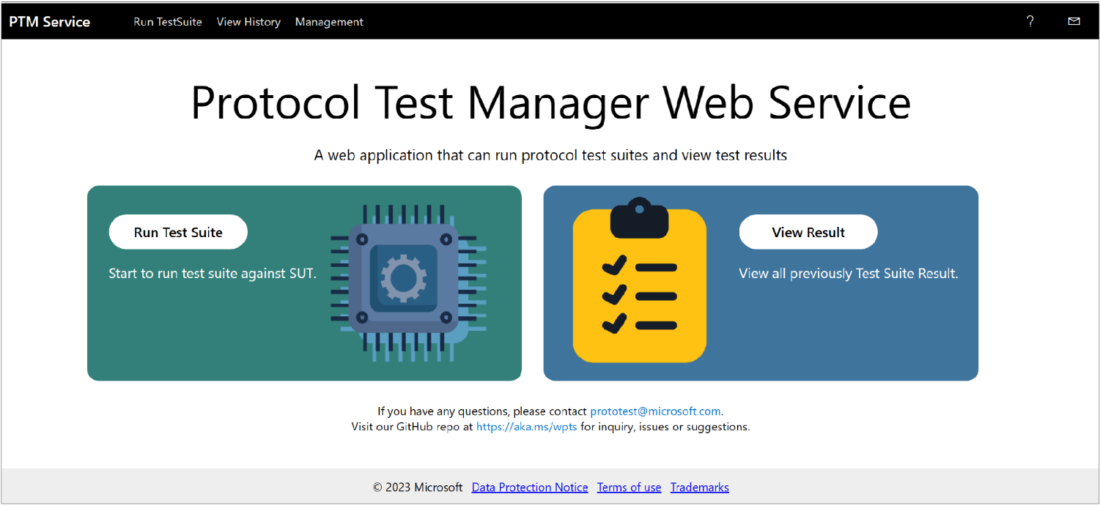

Figure . RDP Client Test Suite: PTM Service landing page

This section provides an overview of the top-level configuration tasks you must perform with the **PTM Service** to create a working **Test Suite** configuration. The top-level tasks display when you click the **Run Test Suite** button shown in the previous figure. The task list is shown to the left in the following figure:

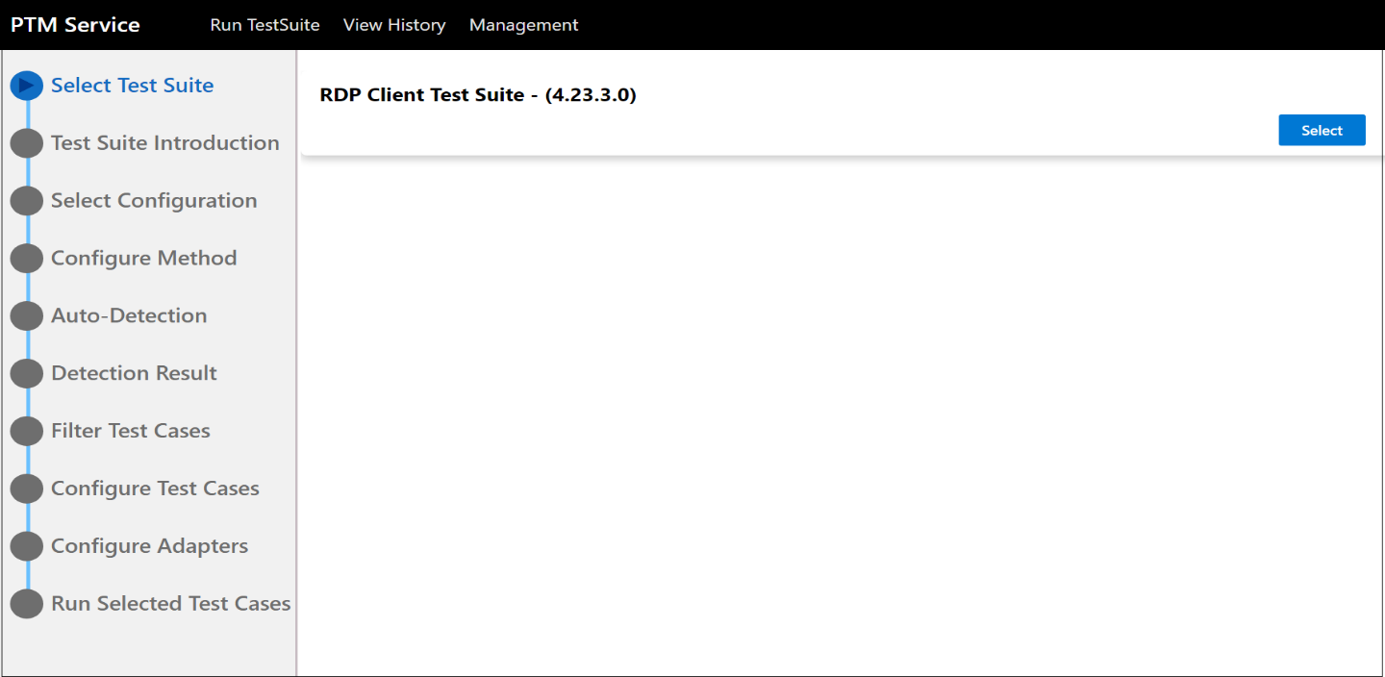

Figure . PTM Service: Tasks list

These tasks are briefly described as follows:

* **Select Test Suite** — enables selection of the **RDPClient – (4.23.3.0) Test Suite** from where you can run your **RDP** **Test Cases**.

 **Note**

By clicking the **Select** button in the right-hand sector of the **Select Test Suite** task, the **Test Suite Introduction** task automatically displays. From the **Test Suite Introduction** task display you can review the family of RDP protocols associated with the **RDP Client Test Suite**, the implementations of which this Test Suite is designed to test.

The introduction also familiarizes you with deployment configurations, such as the **Domain** and **Workgroup** environments, as described in the **Deployment Guide**.

* **Select Configuration** — select this task to specify the Test Suite mode, where you can do any of the following:

Run an existing Test Suite configuration (**Run**)

Update an existing Test Suite configuration (**Edit**) and run.

Create a new Test Suite configuration (**Edit**).

**See Also**: **Create a New Test Suite**

* **Configure Method** — select this task and choose one of the following options:
* **Run** **Auto-Detection** — automatically detects/assesses the **system under test (SUT)** environment and obtains a default configuration of **Test Cases** that you can run, based on the assessment.
* **Do Manual Configuration** — manually configure the **Test Suite** and select **Test Cases**.

[](https://github.com/microsoft/WindowsProtocolTestSuites/blob/staging/TestSuites/RDP/Client/docs/image/RDP_ClientUserGuide/image6.png)**Important**

This option is recommended for advanced users only.

* **Load** **Profile** — enables you to run a **Profile**, which contains a set of **Test Cases** that you previously selected and saved to define a common or baseline set of tests for potential use in troubleshooting one or more targeted features.

For example, you might run a **Profile** to repetitively reapply a common set of **Test Cases** in multiple test runs that focus on a particular RDP feature, property, or protocol, while each time running against a modified version of that **RDP** feature, property value, or protocol to observe the deviations in test results.

There are no restictions on the number of **Profiles** you can create.

**See Also**: **Creating a Profile**

* **Auto-Detection** — select this task to specify input information for locating the **SUT** computer and running a detection routine to confirm **SUT** characteristics, capabilities, and environment compatibility for testing. Input information consists of data such as **SUT Name**, **SUT** **User Name**, **SUT** **Password**, **Trigger RDP Client by**, and so on.
* **Detection Result** — reports the protocols and features that are supported by the**SUT** configuration and verifies **PTM Service** detection, inspection, and validation of the **SUT** environment for test readiness.
* **Filter Test Case/s** — select this task to modify the default output of the **Auto-Detection** process, by selecting (~filtering) **Test Cases** to create a unique test configuration.

 **Note**

You can choose Test Cases to target specific RDP features in order to isolate where errors or questionable outcomes may be occurring in your test results.

* **Configure Test Cases** — select this task to review or optionally reconfigure **Test Case** properties to refine, adjust, or correct one or more property values. In troubleshooting scenarios, you might also deliberately skew a property value to emphasize a potential vulnerability that is otherwise hard to detect.
* **Configure Adapter** — select this task to set the type of control adapters to use and specify script locations as required.
* **Basic RDP SUT Control Adapter** — use this adapter in general, for all **RDP** **Client Test Suite** Test Cases
* **RDPEI SUT Control Adapter** — only use for RDPEI Test Cases
* **RDPEDISP SUT Control Adapter** — only use for RDPEDISP Test Cases

On the **Configure Adapter** page of the **PTM Service** and from the **Type** drop-down of the **Basic RDP SUT ControlAdapter**, use the default setting of **PowerShell**, as shown in **Figure 17**.

 **Notes**

Adapters are applications that help to trigger **SUT** events that are detected by certain Test Cases. Note that you can ignore the **RDPEI SUT Control Adapter** and the **RDPEDISP SUT Control Adapter** settings, given that tests for these adapters are not run in this Tutorial session. Also note that if any other changes are necessary, your Tutorial Instructor will specify them.

* **Run Selected Test Case/s** — select this task when you are ready to run all cases or to run only *selected* **Test Cases** at execution time.

You will complete the tasks described in the previous list in the section **Configure the RDP Client Test Suite Using the PTM Service**, which follows. Thereafter, you will run the Test Cases and then perform simple analysis on test results to obtain a basic understanding of the analysis features.

**Optional Configuration Scenario**

If you have already performed an execution of Test Cases and saved a **Profile** per the procedure in **Creating a Profile**, you can proceed to the section **Configure the Test Suite by Loading a Profile**. In this procedure, you will load a set of Test Cases with associated properties into the **PTM Service** prior to execution, instead of performing the configuration that is specified in the section that immediately follows. However, note that you will need to have the **PTM** **Service**open to the **Configure Method** tab to load an existing **Profile**.

## Configure the RDP Client Test Suite Using the PTM Service

The **PTM Service** is a user interface (UI)-based tool that helps you configure and run **Test Cases**. To access the **RDP Client Test Suite** and the **PTM Service**, you will need to connect with the **Driver computer**, as described herein. The **PTM Service** contains all the features and functions you will need from this point forward to configure, run, and analyze **Test Cases**.

⯈ To access the PTM Service and begin configuration tasks, perform the steps that follow:

1. If you have not done so already, connect with the **PTM Service** on the **Driver computer** by entering the **Driver** computer IP address in a web browser and launching it. This IP address and any other required credentials should have been referred to you on a designated Teams Channel prior to the RDP event. Otherwise, consult your Tutorial Instructor.

The **PTM Service** should automatically display its landing page when you connect, as shown earlier in **Configuring the RDP Client Test Suite**. If it does not, then locate the **PTM Service** shortcut on the **Driver computer** desktop and double-click it to start the service.

To begin the configuration process, click the **Run Test Suite** button on the **PTM Service** landing page to display the **Select Test Suite** task of the **PTM Service**.

1. In the upper-right sector of the **PTM Service** task, click the **Select** button associated with the **RDP Client Test Suite – (4.23.3.0)** version identifier shown in the following figure, to select the latest version of the **RDP Client** **Test Suite**.

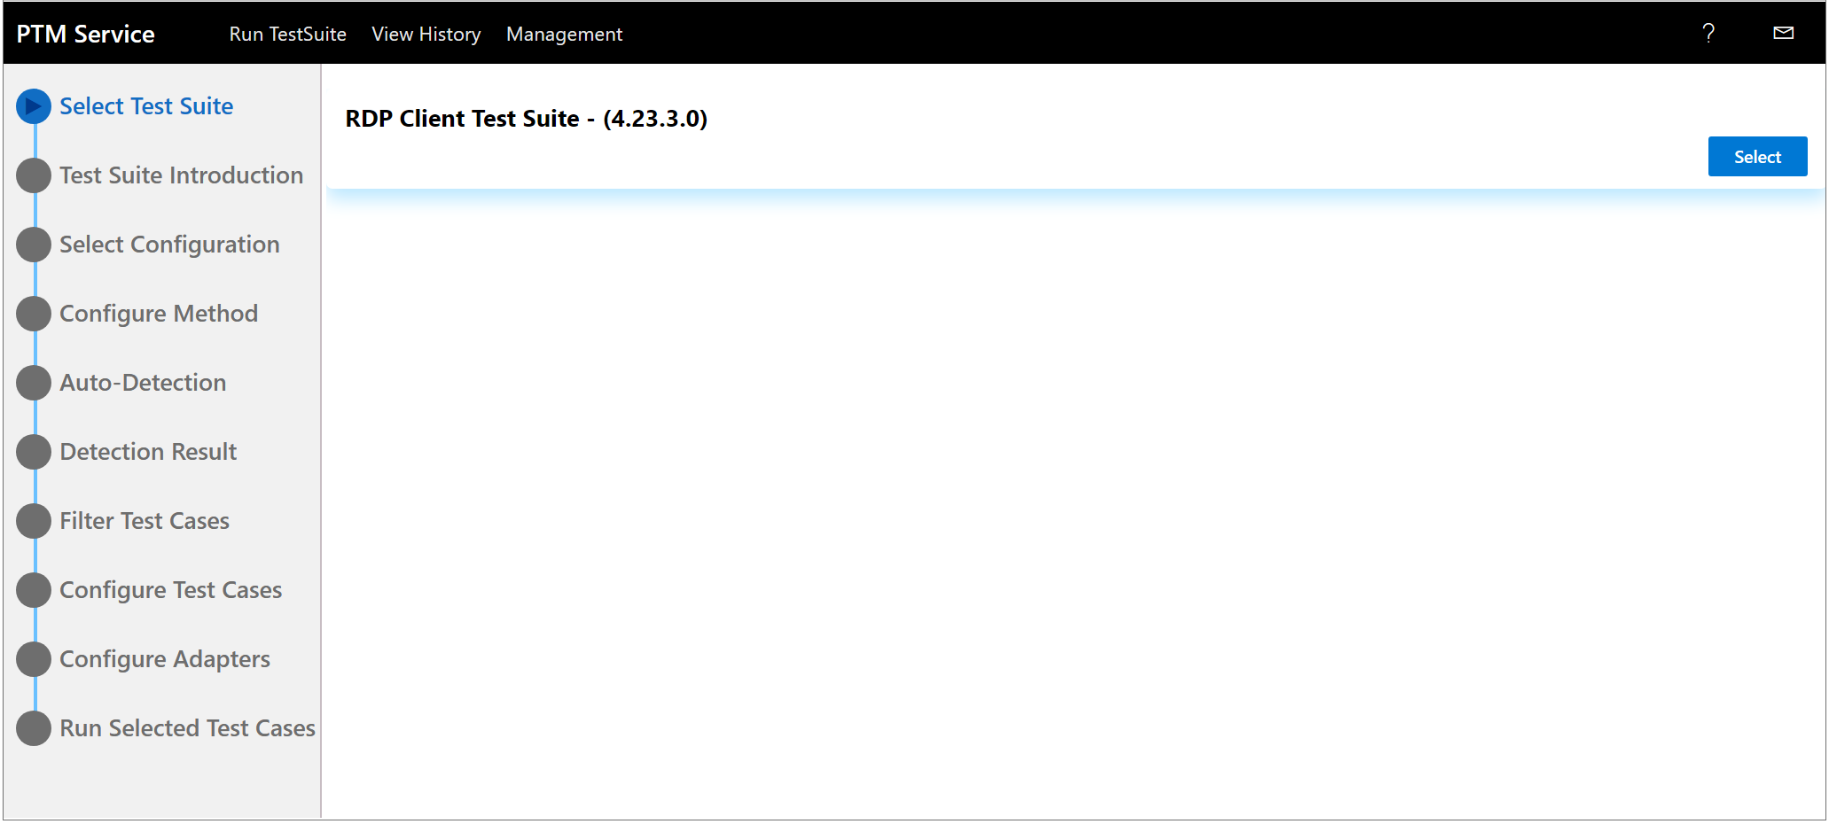

Figure . PTM Service : Select the RDPClient Test – (4.23.3.0) Suite task

1. Observe that the **Test Suite Introduction** task displays with the RDP family of protocols, as shown in the figure that follows.

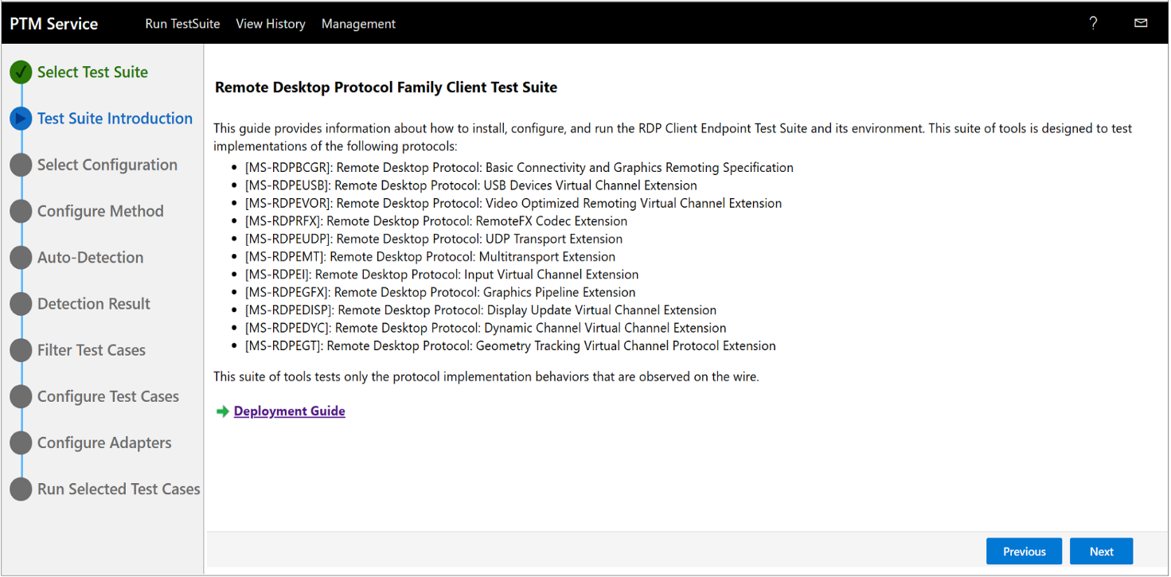

Figure . PTM Service : Test Suite Introduction task - RDP family of protocols

1. Read the protocol information presented in the **Test Suite Introduction** task and then optionally click the **Deployment Guide** link to review general information about the network test environments in which Test Cases are typically run.

 Note

It is unnecessary to click the **Configure Environment** link after reviewing the network test environment information, given that setup and configuration procedures will have already been completed by the Test Team running this **RDP Client Test Suite** **Hands-on Lab (HOL)** event.

1. In the lower-right sector of the **Test Suite** **Introduction** page of the **PTM Service**, click the **Next** button to display the **Select Configuration** task. If there is already an existing **Test Suite** in the **Name** column of the **Select Configuration** task space, click the first of the following actions to proceed, as shown in the figure that follows:

**Run** — click this button to initiate the immediate execution of the Test Cases that currently exist in a **Test Suite** that is specified under the **Name** column.

**Edit** — click this button to modify the Test Cases and properties configuration before executing the **Test Cases**. Note that you will also need to click the **Edit** button if you have created a new **Test Suite** and you need to begin the configuration process.

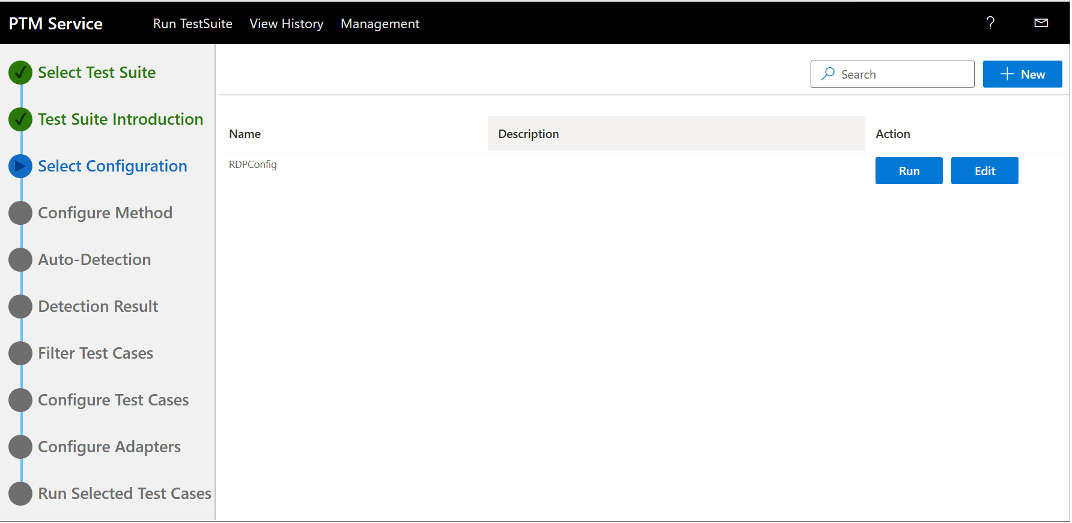

Figure . PTM Service : Select Configuration task space

If there is no **Test Suite** specified in the **Name** column, you can either search for an existing **Test Suite** by typing a test suite name in the **Search** box and clicking the **Search** icon, or you can create a new **Test Suite** to represent a new test configuration, as follows:

⯈  To create a new Test Suite configuration

1. Click the **+ New** button to the right of the **Search** box in the **Select Configuration** task to display the **New Configuration** dialog, as shown in the figure that follows:

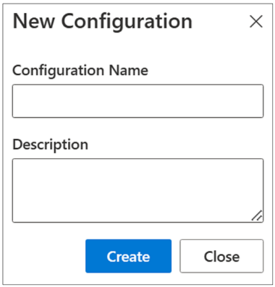

Figure . PTM Service : New Test Suite Configuration dialog

1. In the **Configuration Name** text box, type a name for the new **Test Suite** configuration.
2. In the **Description** text box, type a brief description that will be easily identified in a potentially long list of **Test Suite** configurations.

 Advisory

For example, you might consider naming the test suite configuration and describing it in terms of a bug, fault, or other issue you are trying to resolve. If there is a time-sensitive factor, you could categorize the test suites by critical dates. Also consider that you can categorize according to RDP features or functions that are of particular interest in troubleshooting scenarios. Of course, these are only a few examples.

1. When complete, click the **Create** button to generate the new **Test Suite** name and description.

[](https://github.com/microsoft/WindowsProtocolTestSuites/blob/staging/TestSuites/RDP/Client/docs/image/RDP_ClientUserGuide/image6.png)**Important**

Whenever you create a new **Test Suite**, the configuration name and description you chose appear in the **Name** and **Description** columns, respectively. Also, an **Edit** button is added to the **Action** column for the new **Test Suite**, which you will need to click to begin the configuration process for the new **Test** **Suite**.

If you want to run an existing **Test Suite** and no **Test Cases** are currently running; and if the existing **Test Suite** requires no further configuration changes, you can simply click **Run** to execute the existing (last run) configuration of **Test Cases** while still retaining the existing **Test Suite** configuration settings.

At any time, you can resume creating another **Test Suite** configuration.

1. Click the **Edit** button associated with the Test Suite with which you will be working, to display the **Configure Method** task options shown in the figure that follows.

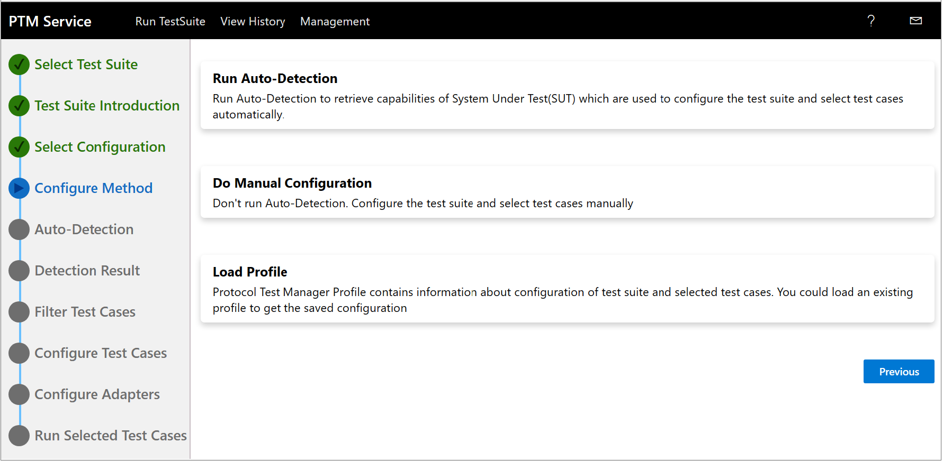

Figure . PTM Service : Configure Method task

1. For the **Configure Method** task options of the previous figure, click the **Run Auto-Detection** option. This is the quickest and easiest method to use for test configuration tasks.

[](https://github.com/microsoft/WindowsProtocolTestSuites/blob/staging/TestSuites/RDP/Client/docs/image/RDP_ClientUserGuide/image6.png)**Caution**

Unless you are adept at Microsoft RDP testing technologies and you understand how to assess the **SUT** environment with respect to manually choosing the correct **Test Cases** and configuring their properties, you are advised to not use the **Do Manual Configuration** option.

However, note that you can use the **Load Profile** option to execute Test Cases from a **Profile**, that is, if you have already created a **Profile**, as mentioned in **Configure the Test Suite by Loading a Profile**.

1. Click **Yes** in the **Warning** dialog that appears and observe that the **Auto-Detection** task configuration displays, as shown in the figure that follows.

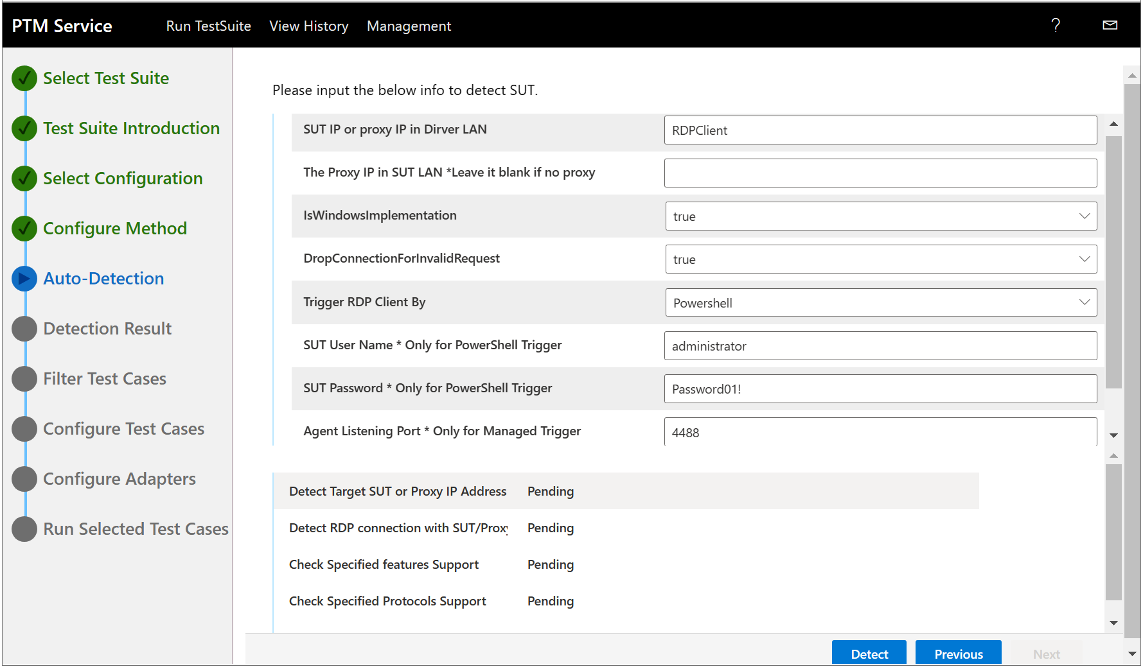

Figure . PTM Service : Auto-Detection task configuration

You may need to specify certain input data that enables the **Auto-Detection** process to locate and verify the **SUT computer** and test configuration. If so, please check with the Tutorial Instructor for guidance.

The processes that are automated by the **Auto-Detection** feature to accomplish such a task include the following:

* Detecting the target **SUT** IP address, or Proxy IP address in the **Driver** LAN
* Detecting the RDP connection with an existing **SUT** proxy IP address (from **SUT** LAN)
* Verifying that the **SUT** is a Windows implementation
* Checking for invalid requests
* Checking if the RDP Client is triggered by PowerShell
* Using the **SUT** username and password credentials for a secure logon
* Establishing the **RDP** **Client** listening port for server messages
* Establishing the **RDP** **Server** listening port for client messages
* Checking for specified features and protocols support
* Assessing the **SUT** environment to generate a default configuration of **Test Cases** that you can run, based on the assessment.

 **Note**

For the **RDP Client Test Suite** Tutorial session, the text boxes in the **Auto-Detection** task configuration should contain values that are customized for this session, making any changes unnecessary. However, in proprietary environments, the input data for the **Auto-Detection** task is customized for that environment and certain data must be input by the user. After **Auto-Detection** begins, the user-entered data is stored in the *.ptfconfig file on the **Driver computer**, as specified in a path similar to the following (certain characters vary from computer to computer, i.e., “TJGZk” in the path below).

C:\PTMService\TJGZk\configuration\2\ptfconfig\RDP_ClientTestSuite.deployment.ptfconfig

For the **RDP Client Test Suite** Tutorial, note that the default values shown in the previous figure will be maintained unless the Tutorial Instructor asks you to change them; otherwise, the default values persist. However, in a proprietary environment, the input values will be unique to the test environment; such as IP address, SUT username, password, and so on. Unique values such as these are added-to and persisted-in the local .ptfconfig file on the **Driver** to reflect the proprietary remote **SUT** configuration.

1. When your review of input values is complete, click the **Detect** button to begin the auto-detection process.

The **Auto-Detection** process completes *only* when all the **Pending** status indicators return as **Finished**. If a **Failure** status is returned, or a process gets hung, consult with the Tutorial Instructor, as you may be unable to continue. Otherwise, proceed to the next step.

1. Click the **Next** button in the lower-right sector of the **Auto-Detection** task configuration to display the **Detection Result** task, as shown in the figure that follows.

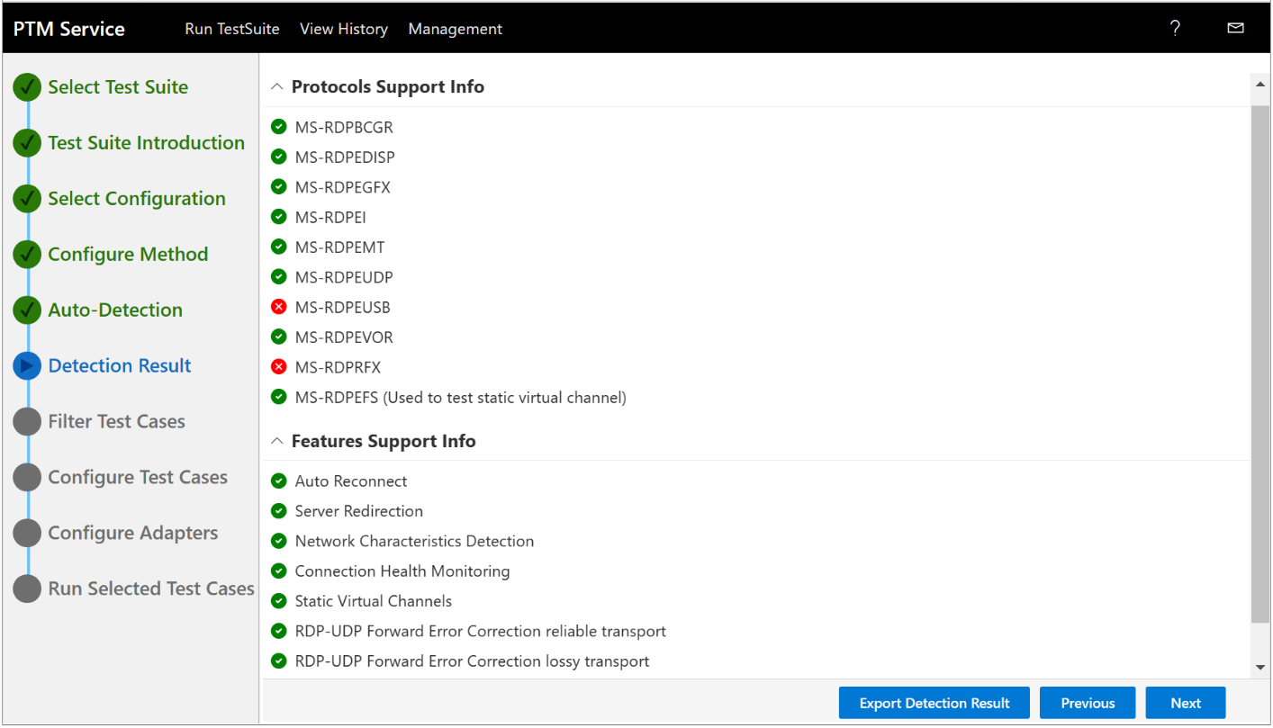

Figure . PTM Service : Detection Results

1. To review the **RDP** protocols that are supported on the **SUT** configuration, click the drop-down arrow to display the list shown in the previous figure.

Supported protocols are indicated by a green circular icon with a white check-mark, while unsupported protocols are indicated by a red circular icon with a white X-mark, as below. To view additional detection information about a particular protocol or feature, click it once to display detection status in the lower sector of the **Detection Result** page:

*  — “<Protocol | Feature> **is found supported after detection**”

Indicates that the assessed entity is supported by the **Test Suite** in the **SUT** environment.

*  — “<Protocol | Feature> **is found not supported after detection**”

An unsupported protocol or feature is flagged with this icon. If selected **Test Cases** attempt to test them, this status indicator will be used to indicate an error in the test results.

**For more information**, see **Test Results Output Status Indicators**.

*  — “**Because of detection failure**, <Protocol | Feature> **is not detected**

**successfully**”

A failure to detect a protocol or feature prevents **Test Case** execution against those entities in the **SUT** environment.

1. To review the **RDP** features that are supported on the **SUT** configuration, click the drop-down arrow to display the list shown in the previous figure.

Supported and unsupported features are identified using the same arrangement of green and red circular icons as described earlier, respectively.

 **Note**

Features are detected as supported or unsupported based on flags set in the Client MCS Connect Initial PDU and Client Confirm Active PDU messages. These messages are shown in the connection sequence overview in section [**1.3.1.1**](https://learn.microsoft.com/en-us/openspecs/windows_protocols/ms-rdpbcgr/023f1e69-cfe8-4ee6-9ee0-7e759fb4e4ee) of **MS-RDPBCGR**.

1. To preserve a record of the supported and unsupported protocols and features, click the **Export Detection Result** button in the lower-right sector of the **Detection Result** task to expose that information as a downloadable HTML rendering of the results.

[](https://github.com/microsoft/WindowsProtocolTestSuites/blob/staging/TestSuites/RDP/Client/docs/image/RDP_ClientUserGuide/image6.png)Important

If you have issues with **Detection Result** values, please consult the Tutorial Instructor or send an email to [**protmail@microsoft.com**](mailto:protmail@microsoft.com).

1. When complete, click the **Next** button in the lower-right sector of the **Detection Result** page to display the **Filter Test Cases** task configuration, as shown in the figure that follows.

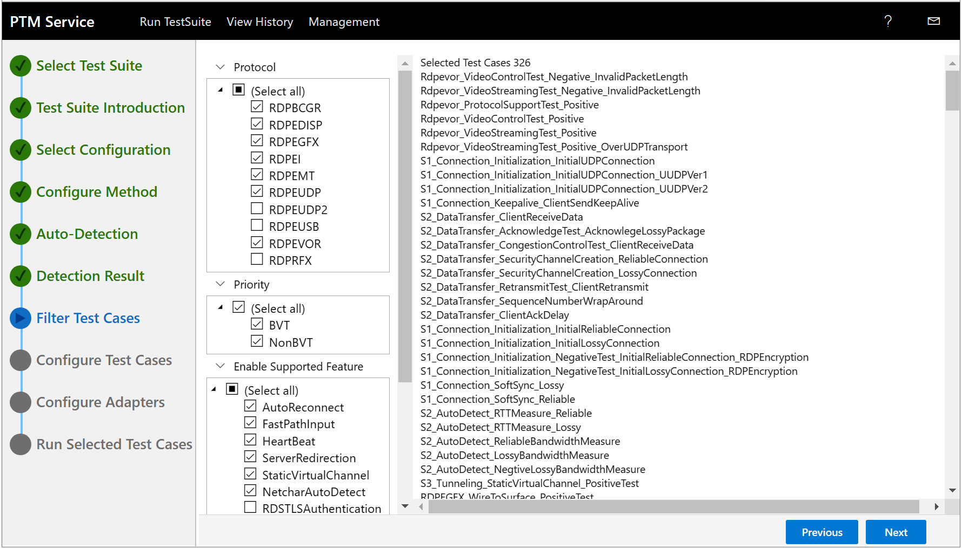

Figure . PTM Service : Filter Test Cases configuration task

The next few steps focus on gaining familiarity with Test Cases, protocols, and features.

1. For the **Filter Test Cases** task configuration of the **PTM Service** shown in the previous figure, briefly review the **Test Cases** in the Test list view to the right, given that they are the default **Test Cases** derived from the **Auto-Detection** assessment of the **SUT** configuration.

 **Tip**

You have the option to run all the default **Test Cases** that will test supported and applicable protocols, that is, to the extent that each protocol facilitates supported feature Tests. You can also select specific features to test and specific protocols to test them.

### Selecting Test Cases

When selecting **Test Cases**, note that at a minimum you must select at least one of the sub-categories in each of the top-level categories described below, to include and activate the associated Test Case/s for a test run. Top-level selection categories and sub-categories are described as follows:

* **Protocol** — reflects the supported RDP protocols under test (from the **SUT** implementation)
* Select one or more protocols to add to a Test Case configuration
* **Priority** — enables you to specify the type of tests to run (**BVT**, **NonBVT**, or both)
* **BVT** — a set of basic tests known as build verification tests (BVTs). These are a special set of Test Cases that perform verification tests to confirm validated **Test Suite** configurations that signal **SUT** readiness for Test Case execution.

For example, the **RDPGBCR** protocol has seven **BVT** tests that are referred to as scenario S1­_Connection tests. These are used to verify client connection and disconnection sequences. In total, the **RDPGBCR** protocol has 10 different scenarios, most of which contain a combination of **BVT** and regular Test Cases. All supported **RDP** Protocols under test similarly utilize a combination of **BVT** and regular Test Cases.

More Information

**To learn more** about Scenario-based testing, see the [**RDP Client Test Design Specification**](https://github.com/microsoft/WindowsProtocolTestSuites/blob/main/TestSuites/RDP/Client/docs/RDP_Overview_ClientTestDesignSpecification.md).

* **NonBVT** — regular **Test Cases** that perform targeted tests of protocols and features that comprise the **SUT** configuration.
* **Enable Supported Feature** — selection activates **Test Cases** to run against supported features discovered in **Auto-Detection**.
* **Specific Requirements** — enables you to specify interactivity levels and device requirements. This includes activating the Interactive testing mode where user interaction is required for completion of some **Test Cases**.

More Information

To learn more about the **Interactive mode**, see the [**Test Run Pre-Configuration**](https://github.com/microsoft/WindowsProtocolTestSuites/blob/main/TestSuites/RDP/Client/docs/RDP_ClientUserGuide.md#test-run-pre-configuration) topic in the [**RDP Client Test Suite User Guide**](https://github.com/Microsoft/WindowsProtocolTestSuites/blob/main/TestSuites/RDP/Client/docs/RDP_ClientUserGuide.md).

### Creating Test Case Configurations

Before proceeding with more complex test configurations, review this section for examples of creating simple test configurations that you may or may not not run right away, at the discretion of the Tutorial Instructor. Nevertheless, the goal is to understand how to create a test configuration that targets a particular feature or protocol in order to return a focused set of test results.

⯈ To create a simple Test Case configuration

1. Make the selections indicated in the Table that follows and observe a Test Case display similar to the figure that follows, where tests will run against the applicable supported features.

Table 2. Test Case configuration - Example 1

|  |  |
| --- | --- |
| **Top-Level Test Category** | **Selection Value** |
| Protocol | RDPBCGR |
| Priority | BVT |
| Enable Supported Feature | Select all |
| Specific Requirements | NonInteractive |

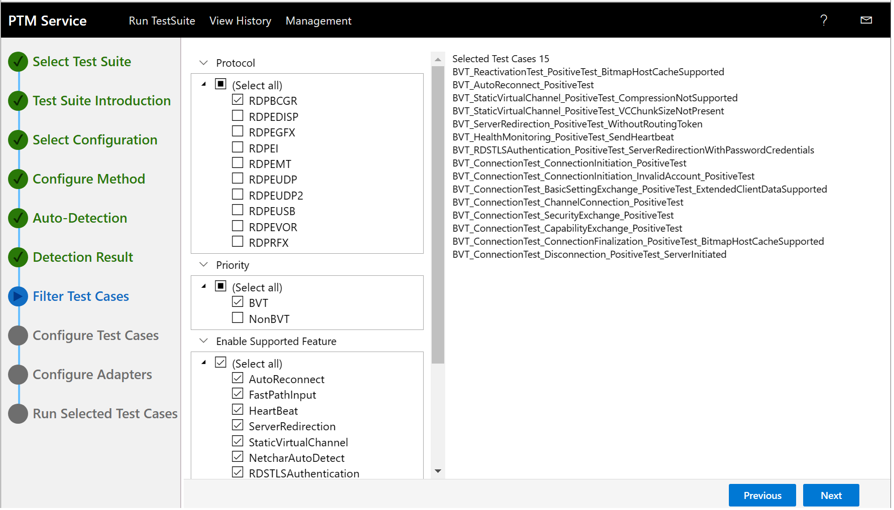

Figure . PTM Service : RDP Protocols, Test Cases, and Feature correlations

1. Repeat this process while varying **Protocol** selections to get an idea of what tests will be run on supported features, that is, from the viewpoint of each protocol that you select.

* For example, suppose you need to verify whether the **AutoReconnect** feature is working properly. You can do this with a simple Test Case configuration such as the following:

Table 3. Test Case configuration - Example 2

|  |  |
| --- | --- |
| **Top-Level Test Category** | **Selection Value** |
| Protocol | RDPBCGR |
| Priority | BVT |
| Enable Supported Feature | **AutoReconnect** |
| Specific Requirements | NonInteractive |

For the **AutoReconnect** feature, note that the Test Case name correlates with the feature selection, as in “BVT_AutoReconnect_PositiveTest”.

* To create a more comprehensive test configuration, you might consider altering the previous configuration by replacing the **AutoConnect** feature with the **Basic Requirement** option, which aggregates multiple Test Cases from other related features listed under the **Enable Supported Feature** category into a single collection of **Test Cases**.

Executing this test configuration can give you a general sense of how the initial connection sequence, basic client/server settings exchange, security exchanges, and other functions of the **RDPBCGR** protocol are behaving in the **SUT** environment.

[](https://github.com/microsoft/WindowsProtocolTestSuites/blob/staging/TestSuites/RDP/Client/docs/image/RDP_ClientUserGuide/image6.png)**Important**

The foregoing examples obviously cover a narrow scope of testing. However, they are only meant as an example of how to approach and simplify what can otherwise be a daunting task of organizing meaningful test configurations, given the hundreds of **Test Cases** that are available from which to choose.

1. Observe the actual outcome of executing these Test configurations later in this session, if the Tutorial Instructor determines there is time to do so.

 **Advisory**

A suggestion for creating a test configuration template on the **Filtering Test Cases** page of the **PTM Service** might be to use a formula of selecting one or more sub-cateory items in each top-level category, as follows:

* **Protocol** — select multiple protocols or isolate a specific protocol to focus Test results
* **Priority** — select **BVT** or **NonBVT**, to organize tests into two main sub-categories of test types
* **Enable Supported Feature** — select multiple features or isolate a specific feature to narrow the focus of Test results
* **Specific Requirements** — in general, select either the **Interactive** or **NonInteractive** mode of operation, depending on whether user interaction is required by Test Cases

1. Experiment with different selection combinations and observe how the Test Cases organize around the selections you make.

If you do not select at least one sub-category in each top-level category, no Test Cases will display. In addition, keep in mind that Test Case names frequently correlate with feature names, which can help you associate the former with the latter.

### Creating the Lab Session Test Configuration

In this section, you will create the Test Configuration that is designed for this **RDP Client Test Suite** Lab Session. The Test results for the executed **Test Cases** in this configuration could serve as an example for analyzing the Test results.

⯈ To create the RDP Client Lab session Test configuration

1. In the **Filter Test Cases** task, unselect the **Select All** checkbox in each top-level Test Category described in the table that follows.
2. From the table that follows, select the values for each **Test Category** as specified in the **Selection Value** column:

Table 4. Lab session Test Case configuration - Example 3

|  |  |  |
| --- | --- | --- |
| **Top-Level Test Category** | **Selection Value** | **Meaning** |
| Protocol | RDPBCGR | A protocol that tests connection sequences, settings, and data exchanges. |
| Priority | BVT | Build verification tests that determine if the **SUT** configuration can continue Test Case execution. |
| Enable Supported  Feature | -- AutoReconnect | Verifies auto-reconnect sequences. |
| -- Heartbeat | Verifies client can receive Server Heartbeat **PDU**; auto-reconnects if not received in fixed time. |
| -- ServerRedirection | Verifies standard security server redirection PDU, and enhanced security server redirection PDUs. |
| -- StaticVirtual Channel | Verifies virtual channel PDUs that transport data between static virtual channel endpoints. |
| Specific Requirements | NonInteractive | Select for Test Cases that do not require user interaction or devices. |

1. Based on the selections in the previous Table, observe the resulting configuration of executable Test Cases in the Test list view below the **Selected Test Cases** label in the figure that follows.

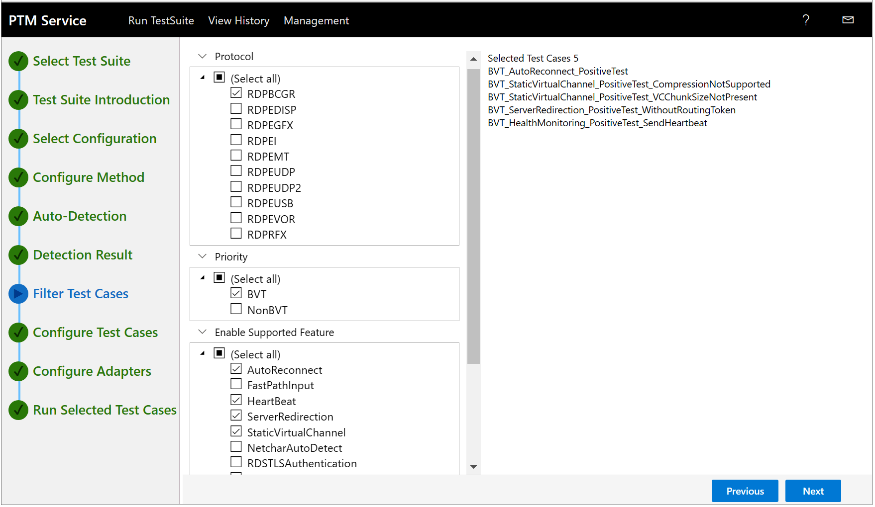

Figure . PTM Service : Tutorial Session Test Case and Feature configuration

1. When ready, click the **Next** button in the lower-right sector of the **Filter Test Cases** task to display the **Configure Test Cases** task shown in the figure that follows.

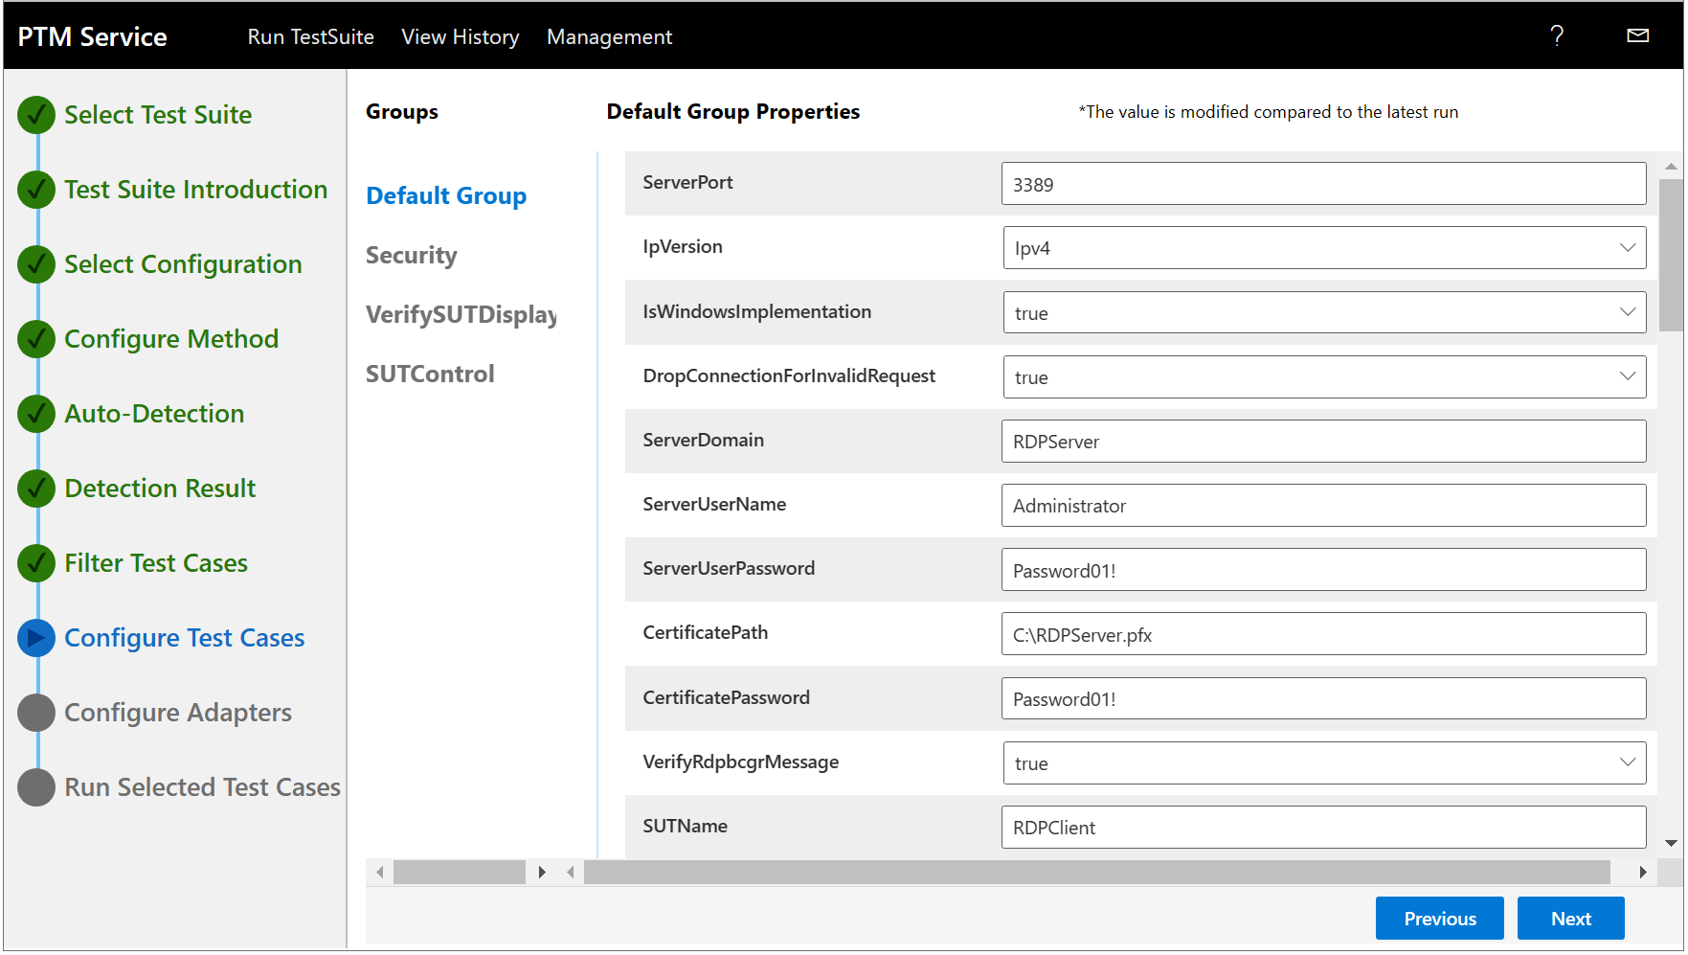

Figure . PTM Service : Reviewing/optionally configuring Test Case properties

1. In the **Configure Test Cases** task properties display, you will see four property **Groups** containing lists of properties and values. Each **Group** contains different properties, described as follows:

* **Default Group** — describes common property settings that are required for all Test Cases, as similarly specified in **RDP_ClientTestSuite.deployment.ptfconfig**.
* **Security** — contains several common properties in Security groups that can be modified for security purposes.
* **Verify SUT Display** — contains several common, variable property settings for Image Quality Assessment (IQA) processing, which includes an image similarity algorithm.
* **SUT Control** — contains properties to support the adapter mode. For example, when UDP is the TransportType, the synthetic server communicates with the **SUT** over UDP.

1. In the **Groups** column, click each property **Group** name to display the property listings contained in each **Group**.

More Information

**To learn more** about these properties and settings, see [**Configuring the Test Suite**](https://github.com/Microsoft/WindowsProtocolTestSuites/blob/main/TestSuites/RDP/Client/docs/RDP_ClientUserGuide.md#configuring-the-test-suite) in the [**RDP Client Test Suite User Guide**](https://github.com/Microsoft/WindowsProtocolTestSuites/blob/main/TestSuites/RDP/Client/docs/RDP_ClientUserGuide.md). In this section, you will find the configuration settings that are required to run the Test Cases of the **RDP Client Test Suite**.

 **Note**

Some properties require specific settings that must be verified in the appropriate configuration file. For example, in proprietary environments, it is likely you will need to verify the displayed properties and values in the **Configure Test Cases** task against the **RDP_ClientTestSuite.deployment.ptfconfig** file for consistency.

1. Scroll through the property values and consult with the Session Instructor if you encounter any value that seems potentially invalid.
2. When ready, click **Next** to display the **Configure Adapters** task of the **PTM Service**, as shown in the figure that follows.

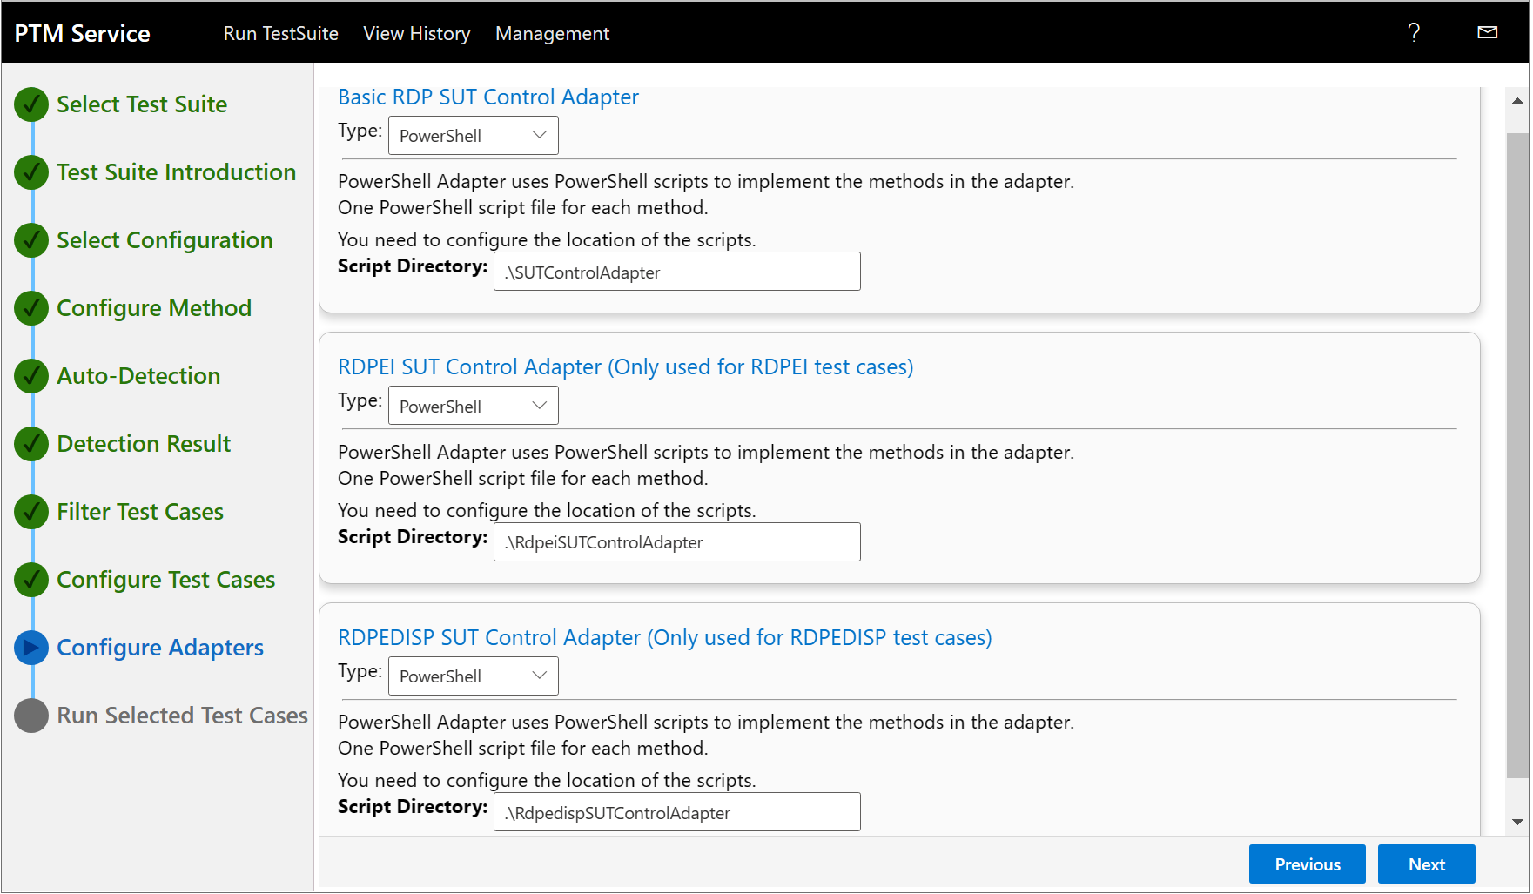

Figure . PTM Service : Control Adapter settings

1. If not already selected by default, click the **Type** drop-down arrow for each Adapter and select the **PowerShell** mode. You can also set other modes if required, as follows.

**PowerShell** — Test Cases automatically control the RDP client (SUT) via the PowerShell script that is executing.

**Interactive** — Test Cases display dialog boxes to guide you in the performance of manual test steps.

**Managed** — an agent receives **SUT** control requests from the Test Suite and thereafter enables Test Case execution on the SUT. To control the RDP client system, the agent must be implemented on the RDP client (SUT) in accordance with the [**RDP SUT Remote Control Protocol**](https://github.com/microsoft/WindowsProtocolTestSuites/blob/main/TestSuites/RDP/RDPSUTControlAgent/Docs/SUT_Remote_Control_Protocol.md) documentation.

More Information

**To learn more** about Test Suite adapter modes, see [**Configuring Common Test Suite Mode Settings**](https://github.com/Microsoft/WindowsProtocolTestSuites/blob/main/TestSuites/RDP/Client/docs/RDP_ClientUserGuide.md#configuring-common-test-suite-mode-settings) in the [**RDP Client Test Suite User Guide**](https://github.com/Microsoft/WindowsProtocolTestSuites/blob/main/TestSuites/RDP/Client/docs/RDP_ClientUserGuide.md).

1. When complete, click **Next** in the lower-right sector of the **Configure Adapters** task to display the **Run Selected Test Cases** task of the **PTM Service**, as shown in the figure that follows.

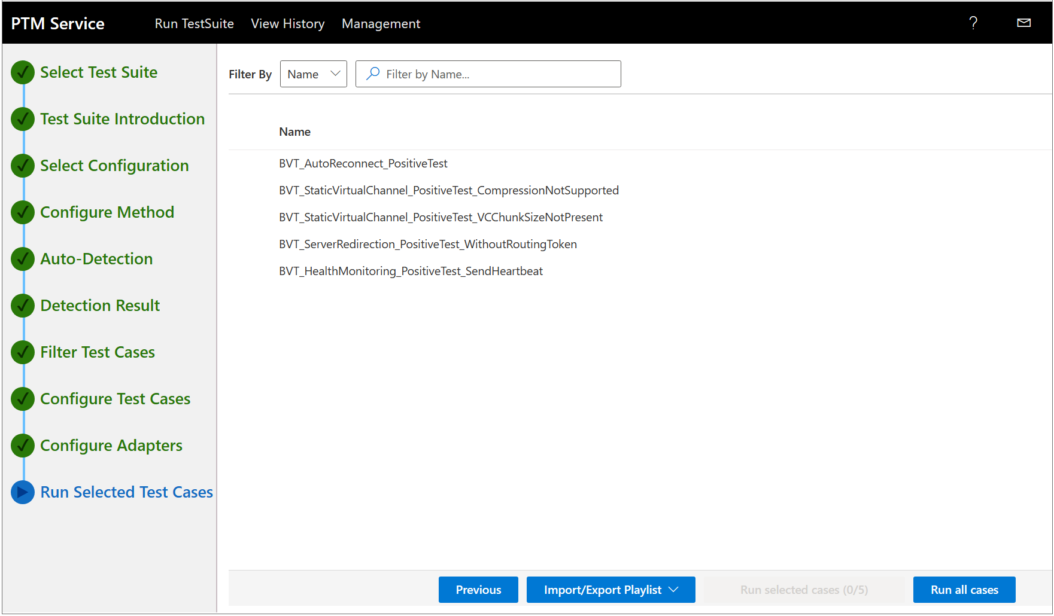

Figure . PTM Service : Test Case Execution Configuration

1. In the Test Case list view, mouse-hover over the **Name** label until a radio button appears; then click it to check all the Test Cases, which thereby enables them for test execution.

This completes the configuration phase of the **PTM Service** for the RDP Lab Session Test Configuration. If you are ready to run your Test Cases, go to **Running the Test Cases : Options**.

## Configure the Test Suite by Loading a Profile

If you have previously saved one or more **PTM** **Profiles**, as described in **Creating a Profile**, follow the procedure in this section to load a **Profile** with the **Load Profile** option of the **PTM** **Service**.

This action results in configuring the test environment with a specified **Test Case** configuration (including supporting property values) that you previously saved as a **Profile**. For this session, the RDP Session Test Case Configuration was preserved as a **Profile** for consistency and downloaded for execution in the procedure that follows.

 **Note**

After you have loaded the Test Cases of a saved **Profile** into the **PTM Service**, you can execute the Test Case configuration as is, or modify it prior to starting test execution.

⯈ To load a PTM Profile and execute the Test Cases it contains:

* 1. In the **Configure Method** task of the **PTM Service**, click the **Load Profile** method to display the **Load Profile** dialog, as shown in the figure that follows.
  2. In the **Package** textbox of the **Load Profile** dialog, click the folder icon to display the **Open** dialog and navigate to the location where you saved a **Profile**.

If the **Open** dialog does not open to the user **Documents** folder by default, navigate to it manually. If you stored one or more **Profiles** in a different directory location when performing the procedure in **Creating a Profile**, navigate to that location.

1. After the **Load Profile** dialog populates with a <*Profile.ptm*> file name, click the **Load Profile** button in the **Load Profile** dialog to load the **Profile** Test Cases into the **PTM Service**.

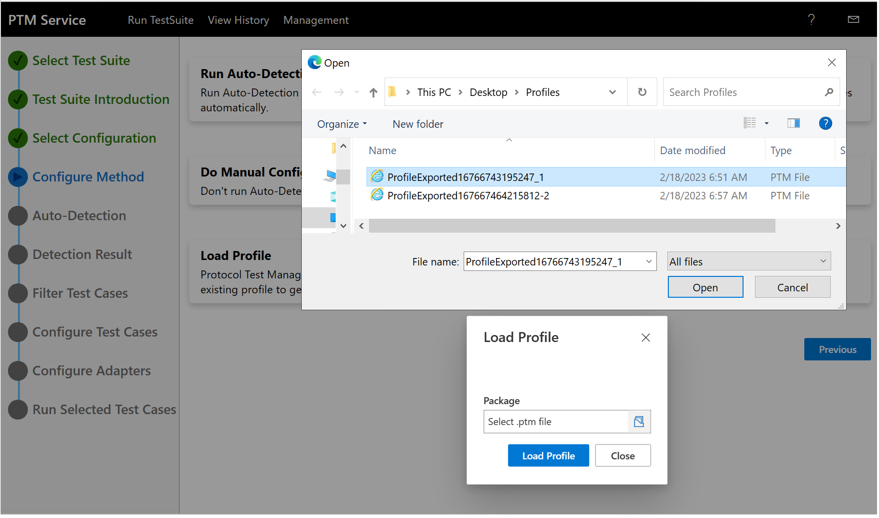

Figure . PTM Service : Loading an existing Profile

1. Observe that the **PTM Service** immediately opens to the **Run Selected Test Cases** task with the Test Cases loaded but not selected.
2. Review the Test Cases to ensure they appear as expected.
3. Mouse-hover over the **Name** label above the Test Case list view until a radio button appears and then click it to select all the Test Cases with a check-mark, thus enabling execution of all tests.
4. To run the loaded **Profile** **Test Cases**, click either of the following:

* **Run selected test cases** (5/5) — the parenthetical label reflects the number of Test Cases selected out of the total number of existing Test Cases. Only the *selected* Test Cases will execute when you click this button.
* **Run all cases** — note that all Test Cases displayed in the Test list view will execute when you click **Run all cases**, even if one or more Test Cases are unselected.

 Notes

For this particular **Profile**, there are 5 Test Cases, so either option will execute all the Test Cases.

The profiled Test Cases should run the same way as any other set of Test Cases do, with all the status indications that occur during normal Test Case execution progress. When complete, you can proceed to Analyzing the Test Results Data.

[](https://github.com/microsoft/WindowsProtocolTestSuites/blob/staging/TestSuites/RDP/Client/docs/image/RDP_ClientUserGuide/image6.png)Important

If you want to preserve any *selection* or *property* changes you make to the Test Cases in a **Profile**, you will need to create a new **Profile** to save them, as facilities for editing a **Profile** do not exist at this time. To create a new **Profile**, use the **Export Profile** feature in the test results **View History** records of the **PTM Service** and refer to the topic **Creating a Profile** for further procedural information.

# Running the Test Cases : Options

The following options are available for running **Test Cases** from the **Run Selected Test Cases** tab of **PTM Service**. For this Tutorial, you will use the latter option (**Run selected cases**) to run the Test Cases:

https://github.com/Microsoft/WindowsProtocolTestSuites/raw/staging/TestSuites/FileServer/docs/image/FileServerUserGuide/image2.png**Important**

**Do not execute Test Cases at this time.**

**Only perform execution from the procedure** **To run the Test Cases** **ahead.**

* **Run all cases** — click this link to run all Test Cases.

If you select this option, all Test Cases that exist for the **Run Selected Test Cases** task of the **PTM Service** will be executed, whether or not the Test Cases are actually selected. These Test Cases are the ones you were directed to select earlier for the **Filter Test Cases** task of the **PTM** **Service** and therefore appear in the **Run Selected Test Cases** task, as highlighted in the figure that follows.

This option *does not mean* you will be executing *all* the default Test Cases returned from Auto-detection of the **SUT** configuration, given that you *selected* only some of them.

* **Run selected cases** — click this link to run the selected Test Cases.

If you select this option, only the Test Cases that are *specifically* *selected* will be executed.

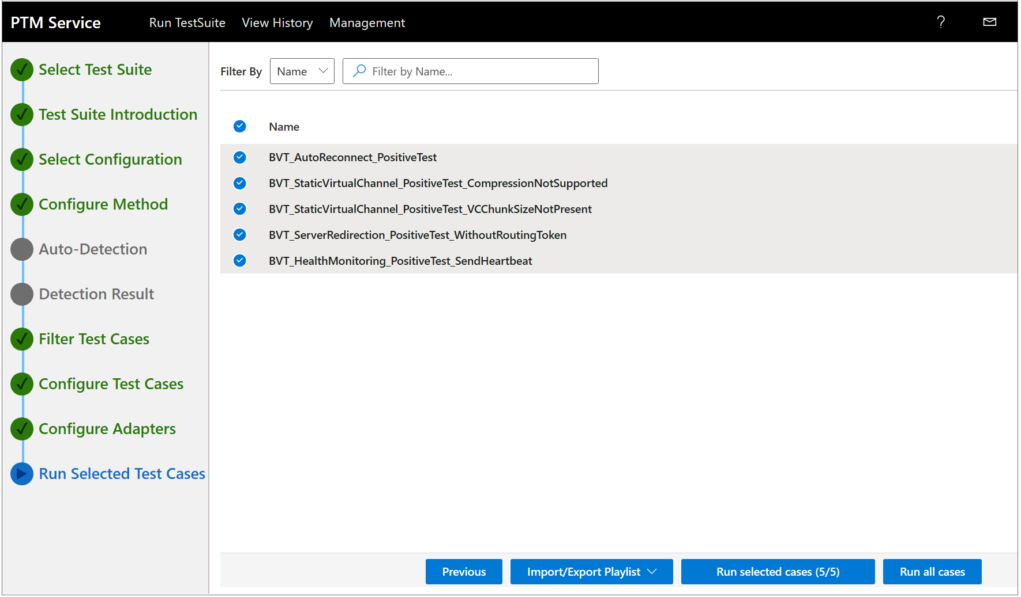

Figure . PTM Service : Running the Test Cases

## Monitoring Test Case Execution Results Indicators

After you start **Test Case** execution, a **Running** indication for the Test Cases appears in the **Status** column of the **View History** pane of the **PTM Service**. When the Test Cases have successfully completed execution, the **Status** indicator changes to **Finished** or **Failed**. As Test Cases progress to completion, other high-level results indicators can display as well, as shown in the table that follows.

Table 5. Test Case status indicators

|  |  |  |  |  |  |  |
| --- | --- | --- | --- | --- | --- | --- |
| **Test Status** | | **Total** | **Passed** | **Failed** | **Inconclusive** | **Not Run** |
| Running | Finished | Count of tests run | Count of tests passed | Count of tests failed | Count of tests inconclusive | Count of tests not run |
| **Example data**: | | 5 | 3 | 0 | 2 | 0 |

The top row of the table reflects the Test Case statistics that are monitored; starting with the second row, it describes what the statistics monitor; and the third row above provides an example of the counts, as also shown in the figure that follows.

Figure . PTM Service : Test Case execution status monitoring

As Test Case execution progresses, you can observe the values in these categories being incrementally updated:

* **Passed** — provides a current/dynamic indication of how many tests have passed, out of the total number selected for execution.
* **Failed** — provides a current/dynamic indication of how many tests have failed, out of the total number selected for execution.
* **Inconclusive** — provides a current/dynamic indication of the tests that were inappropriate, unsupported, or the result of misconfiguration in the test environment.

For example, if a property set from the **Configure Test Cases** task in the **PTM Service** is incorrectly configured, or a Test Case conflicts with an unexpected or invalid property value, that Test Case can finish as **Inconclusive**.

[](https://github.com/microsoft/WindowsProtocolTestSuites/blob/staging/TestSuites/RDP/Client/docs/image/RDP_ClientUserGuide/image6.png)Important

Whenever any of the selected Test Cases in the test environment do not support certain features, errors can appear in the **PTM Service** test results with respect to methods that failed when attempting to test those features.

Notwithstanding errors from actual failures, you can avoid this in an outside/proprietary test environment by running only Test Cases that support the features of that environment. However, note that the **RDP Client Test Suite** **HOL Tutorial** environment in which you are running Test Cases avoids feature errors by simply running only the recommended Test Cases for this test environment.

More Information

**To learn more** about Test Cases and the tests they perform, review their descriptions in the [**RDP Client Test Design Specification**](https://github.com/microsoft/WindowsProtocolTestSuites/blob/main/TestSuites/RDP/Client/docs/RDP_Overview_ClientTestDesignSpecification.md#2.2.1).

## Using the PTM Service to Execute the Test Cases

If you have completed setting up the test environment as described in **Configure the RDP Test Suite Using the PTM Service**, you can start **Test Case** execution by following the steps of the procedure that follows.

⯈ To run the Test Cases:

1. If you are ready to run all the Test Cases, click the **Run all cases** button in the lower sector of the **Run Selected Test Cases** task of the **PTM Service** to execute all Test Cases, regardless of whether any Test Cases are designated as selected or not.
2. If you want to run only the Test Cases you select, choose the Test Cases you want to run in the Test Case list view by clicking them one at a time.

This results in placing a check mark next to each case you select, as shown in the figure that follows. Note that this action *does* *not* trigger execution of any Test Cases.

1. When your selections are complete, click the **Run Selected Test Cases** button to begin execution of selected Test Cases only.
2. While the Test Cases are executing, observe the incremental **Status** indications that appear in the **Passed**, **Failed**, **Inconclusive**, and **Not Run** columns on the **View History** page of the **PTM Service**.

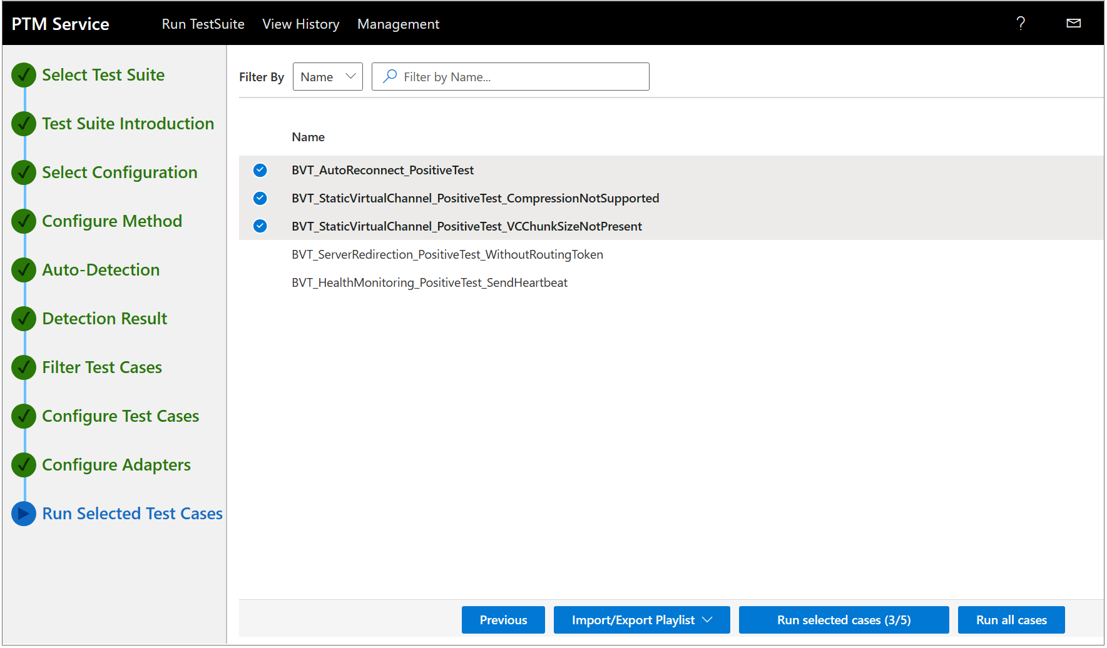

Figure . PTM Service : Selecting and executing Test Cases

You can also view the results of Test Case execution in the command consoles that host the test execution of scripts such as .ps1 (PowerShell) and .sh (Shell) scripts from the following directory location on the **Driver computer**:

* 1. C:\RDP-TestSuite-ClientEP\Batch\

However, note that the **PTM Service** makes the results more accessible and understandable through categorization, summaries, and status indicators, as described in**Analyzing the Test Results Data**.

To learn about analyzing the results of Test Case execution, which includes descriptions of what was tested by any Test Case that you select, proceed to**Analyzing the Test Results Data**. Otherwise, review the topics that follow to learn about creating a **Profile** and using the **PTMCli.exe** command line tool to execute the Test Cases of a **Profile**.

## Creating a Profile

After you complete test execution based on a particular **Test Suite** configuration, as described in **Using the PTM Service to Execute the Test Cases**, you have the option to designate the executed **Test Case** configuration as a **Profile** that you can re-run on demand. You can also intentionally create a **Test Case** configuration that targets one or more particular features so that you can return specific test results of interest, typically for troubleshooting purposes.

Thereafter, you can analyze the **PTM Service** output results data on the **View History** and **View Results** pages, just as you would for any other set of test results.

[](https://github.com/microsoft/WindowsProtocolTestSuites/blob/staging/TestSuites/RDP/Client/docs/image/RDP_ClientUserGuide/image6.png)Important

You must *select* your chosen Test Cases in the **Run Selected Test Cases** task of the **PTM Service** before creating a **Profile**, or no Test Cases will execute. This is especially important if you intend to load a **Profile** later on and thereafter to use the **PtmCli** command line tool with the -s switch, which enforces that only *selected* Test Cases will be executed in a **Profile**. See [**Using a Command Line Tool to Execute Test Cases**](#_(Using_a_Command) for more information about **PtmCli.exe**.

You can optionally create a **Profile***before* actually running the Test Case configuration of your Test Suite, but in this instance, you will not have the advantage of knowing if the Test Case configuration performed well or not. For this reason, you might consider waiting until the Test Cases have finished executing and you’ve had a chance to review the test results, before you create your **Profile**.

This can help you determine if such results meet the requirements of the **Profile** you want to create, that is, in terms of whether it will satisfy the purpose for which you are creating it. For example, you might want a test results baseline, free of inherent **Errors** and **Inconclusive** results, for a certain set of **SUT** features you plan to re-test for comparison after making changes to an **RDP** **protocol implementation**.

You are therefore advised to make use of a **Profile** only after first running the **RDP Client Test Suite** Test Cases at least once and then saving a **Profile** that extracts the selected Test Cases and associated property value information that accompanies them.

**Create a Profile** — create a **Profile** by performing the steps that follow.

⯈ To create a Profile that encapsulates the currently selected Test Case configuration:

1. In the **Run Selected Test Cases** task of the **PTM Service**, ensure you have placed a check-mark on all Test Cases you want to include in your **Profile**, then start Test Case execution.
2. After Test Case execution is complete, locate the name of the corresponding test suite in the **Test Suite** column on the **View History** page of the **PTM Service**.
3. Select the Test Suite on the **View History** page, as shown in the figure that follows, then scroll to the right until you see the **Action** column.
4. Click the **Export Profile** button in the **Action** column to generate the **Profile**, which you can access via a download.

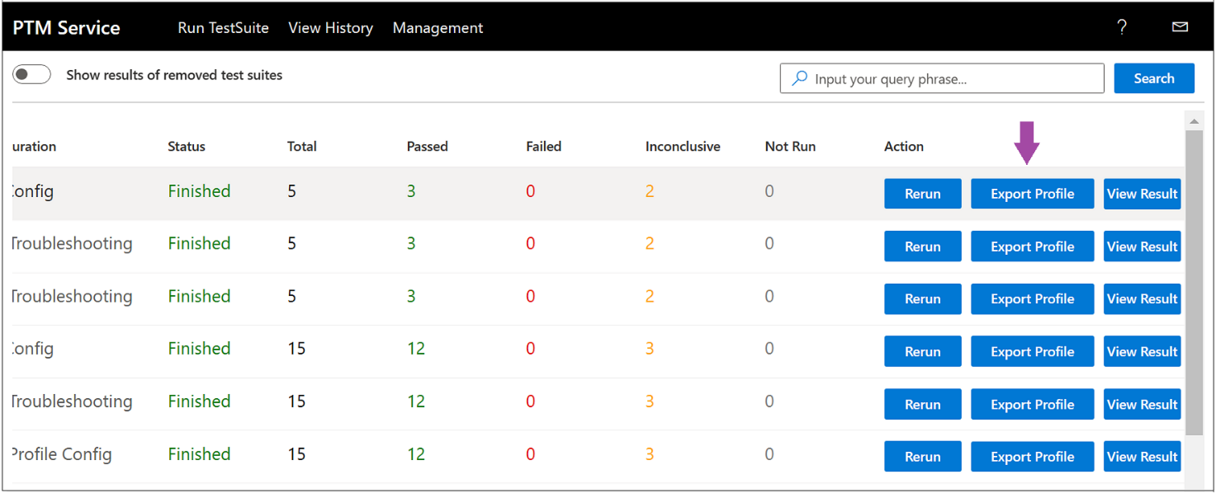

Figure . PTM Service : Creating and Saving a Profile

1. In the **Downloads** dialog that appears, click **Open File** to open the **Internet Explorer** dialog and then choose **Save As** to navigate to a **Save As** dialog where you can rename the **Profile** and save it with a *.ptm extension.

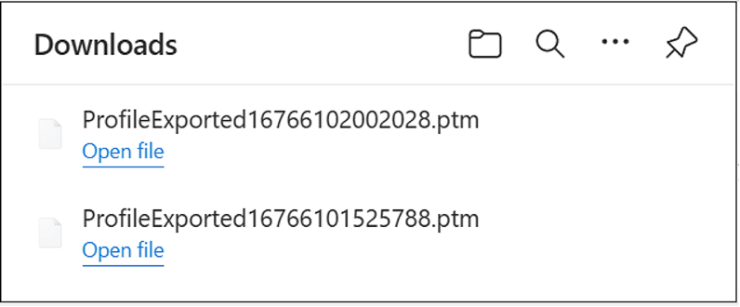

Figure . PTM Service : Saving a Test Case configuration as a Profile

When renaming a **Profile**, preferably use a name that is associated with the type of tests in the Profile; for example, “BVT”, as related to a feature name, or some other designation.

**Run Test Cases on Demand** — after you create a **Profile**, you can then use it in subsequent re-runs of the profiled test environment, where you access the **Profile** via the **Load Profile** option of the **PTM Service**, as described in **Configure the Test Suite by Loading a Profile**. You can also use the **PtmCli** command line tool to execute the Profile’s Test Cases from the command line (see [**Using a Command Line Tool to Execute Test Cases**](#_(Using_a_Command)).

## Working with Playlists

In the **Run Selected Test Cases** task of the **PTM Service**, you have access to the **Import/Export Playlist** feature that allows you to save a set of Test Case names that you can retrieve at any time as a set of test records. A **Playlist** is an XML file that contains a list of Test Cases for which you can preserve a record.

For example, if you want to retain a unique set of Test Cases that are of significance to you, without actually running the tests, but rather to return to later for additional testing, you can use this feature to do so. Note that when you save a playlist with the **Import/Export Playlist** feature, it does not associate the Test Case configuration data with saved Test Cases such as a **Profile** does. The **Import/Export Playlist** feature is shown in the figure that follows.

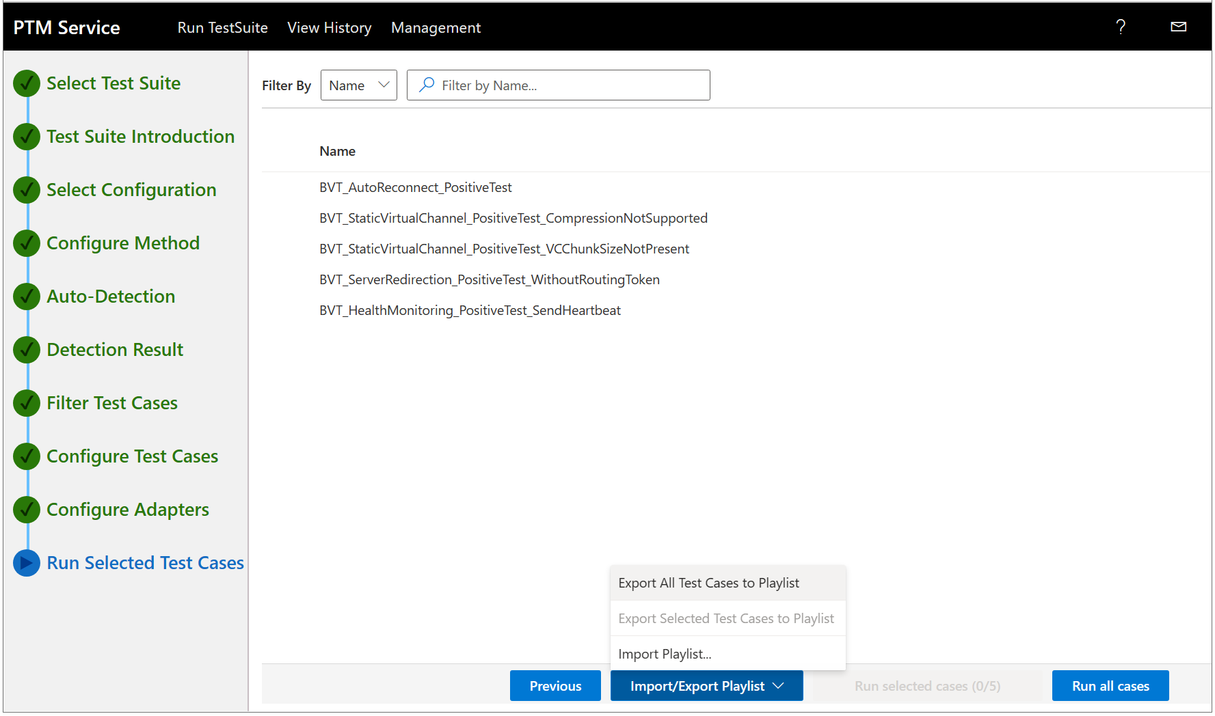

Figure . PTM Service : Creating and saving a Playlist

The options that are accessible from the **Export / Import** dialog are defined as follows:

* **Export All Test Cases to Playlist** — use to export *all* Test Cases to a playlist in a format that is supported by Microsoft Visual Studio.
* **Export Selected Test Cases to Playlist** — use to export *selected* Test Cases to a playlist in a format that is supported by Microsoft Visual Studio.
* **Import Playlist** — use to import a previously exported playlist.

## Using a Command Line Tool to Execute Test Cases

The **PTM Service** enables you to execute the **Test Case** configuration of a previously saved **Profile** (see **Creating a Profile**) with the use of a simple command string. You will trigger execution of **Test Cases** with this command string from a **Driver** **computer** console. You can also do so remotely using a Powershell or Shell script with **Secure Shell (SSH)**.

The application that enables you to do this is known as **PtmCli**, as in *Protocol Test Manager Client*, which you can run on a Windows, Linux, or a macOS platform. You can download the archive [**here**](https://github.com/microsoft/WindowsProtocolTestSuites/releases/download/4.23.3.0/PTMCli.zip) (PTMCli.zip) and extract the contents to a specified folder of your choice on the **Driver** computer.

To execute the Test Cases of a **Profile** by using a command string, perform the procedure that follows:

[](https://github.com/microsoft/WindowsProtocolTestSuites/blob/staging/TestSuites/RDP/Client/docs/image/RDP_ClientUserGuide/image6.png)Important

You *should not* run the **PtmCli** application while the PTM Service is running or an error will occur.

⯈ **To load and execute a Profile from the command line:**

* + - 1. From the **Start** menu, type “Cmd” and then double-click the **Command Prompt** icon.
      2. From the command line, navigate to the folder location you specified above on the **Driver** computer where the **PtmCli** application resides.

1. At the command line, type the following command string:
   * + 1. dotnet PtmCli.dll -p <profilepath> -t <TestSuitePath> -s

Note the following:

* -p switch — requires the directory path specification to a saved **Profile**.
* -t switch — requires the path to locate the **RDP Client Test Suite** on the **Driver** computer, as described just ahead.
* -s switch — enforces execution of only the Test Cases that were selected at the time the **Profile** was saved.

1. Press the **Enter** key on your keyboard and confirm that the Test Case execution results begin to appear in the command console.

 Note

For additional information about the functionality that is available with the **PtmCli** tool, use the --help switch to display it:

* + 1. dotnet PtmCli.dll --help

**PtmCli Help**

The PtmCli application help components are described as follows:

**-p --profile** — a required argument that specifies the path to the **Profile** to run.

**-t --testsuite** — a required argument that specifies the path of the Test Suite to run.

The **RDP Client Test Suite** is installed by downloading the [**RDP Client Test Suite**](https://github.com/microsoft/WindowsProtocolTestSuites/releases/tag/4.23.3.0) zip file from Git Hub. The zip file can be stored on the **Driver** machine in the following optional path. However, note that you can store it in an alternative, preferred location instead:

* 1. C:\RDP-TestSuite-ClientEP.zip

Thereafter, use the -t switch to locate the **RDP Client Test Suite** zip file on the **Driver computer**, as indicated in the previously specified command string.

**-s --selected** — default state is false where all test cases in the **Profile** are executed; otherwise, when this switch is specified, only the test cases selected when the Profile was saved are executed.

**--categories** — specifies the value-separated categories of test cases to run. This parameter overrides the Profile test cases.

**-r --report** — specifies the result file for a report that is to be written to.

**-f --format** — default format is plain text; valid format values are: plain, json, and xunit.

**--outcome** — default values are Pass, Fail, and Inconclusive (comma or space-separated). Specifies the outcome/value of Test Cases to be included in the report file.

**-d --debug** — default state is false, otherwise when specified, PtmCli debugging is enabled. Note that the log file can be found under the current directory where you are running PtmCli.

**--help** — displays this help screen.

**--version** — displays version information.

**Multi-instance Support**

PtmCli supports multi-instance use, meaning that you can run multiple PtmCli executables at the same time. For example, you can open two command consoles on a Windows platform and execute the commands in each window, as follows:

* 1. dotnet PtmCli.dll -p C:\test1.ptm -t C:\RDP-TestSuite-ClientEP
  2. dotnet PtmCli.dll -p C:\test2.ptm -t C:\RDP-TestSuite-ClientEP

The outcome will be two sets of results under the following directory on the **Driver** computer:

* 1. C:\RDP-TestSuite-ClientEP \bin\HtmlTestResults\

# Analyzing the Test Results Data

After Test Case execution is complete, you can view the details of the execution results. The **PTM Service** provides a number of tools and displays that can quickly point you to the causes of Test Case failures or other issues. Some of the most important things to remember are as follows:

* The results that are likely to be of the most interest are the Test Cases that **Failed**. Secondly, the Test Cases that finished as **Inconclusive** can also be of interest, as these might suggest misconfigurations, such as invalid Test Case properties or settings. This could also mean that a selected protocol was inappropriate for a selected feature.
* The **PTM Service** enables you to utilize various status indicators, color codings , information tags, and results filtering that can help you expose the cause of failures or other unexpected results.
* Consider that specifying carefully chosen Test Cases for the **Filter Test Cases** task of the **PTM Service** is a troubleshooting tool that you should utilize. This filtering technique helps you to isolate specific test results and generate a more focused test results context by targeting certain areas of functionality or process.

For example, you might focus on certain RDP operations that you suspect could be problematic, certain BVT tests that can expose basic test results in multiple areas, and RDP connection negotiations or set up processes that might expose invalid RDP settings that were exchanged between the RDP server and client.

* Lastly, the RDPBCGR protocol is typically considered the core RDP protocol, while other protocols in the RDP family are generally extensions of the core. Therefore, when failures arise from Test Case execution, it seems plausible that RDPBCGR would be a good place to begin troubleshooting. Please keep this in mind as you are assessing where to begin analysis of test results data.

 Note

Outside the space of this Tutorial and associated Lab environment, developers who are using a Microsoft Test Suite to test a real-world protocol implementation can similarly utilize the **PTM Service** analysis features to verify the outcome of custom Test Case execution as **Passed**, **Failed**, or **Inconclusive**. Each of these indications can be of equal importance when it comes to resolving issues that are critical to a successfully functioning protocol.

## Test Results Output and Status Indicators

Some of the status indicators that you will encounter as you review your test results are described in the table that follows:

**Table 6. Test results status indicators**

|  |  |  |
| --- | --- | --- |
| **Status Indicator** | **Description** | **UI Location** |
| Initial Test Results Status summary | Results display as the number of Test Cases that passed, failed, or were inconclusive. | The initial Test Case results display configuration is shown as expandable **Passed**, **Failed**, and **Inconclusive** top-level results Category drop-down lists in the left-hand sector of the **View Result** page of the **PTM Service**. |
| Detailed Results | Appears as the default Test Case output configuration on the **View Result** page of the **PTM Service**. | The results of a Test Case appear in the right-hand sector of the **View Result** page of the **PTM Service**, that is, when a Test Case is selected in the left-hand sector of the same page.  For example, one of the first result details typically begin with a **[TestInProgress]** information tag or a **[Comment]** tag that describes the general purpose of the Test Case or the execution time.  It then exposes the sequence in which **[TestSteps]** executed, which can be interleaved with one or more **[Debug]** tags for each **[TestStep]**, whichreflectsinvoked methods, process data, or status resulting from the step.  Also, checks are made along the way which result in either a **[CheckSucceeded]** or **[CheckFailed]** outcome. The final result of the Test Case could be a **[TestPassed]**, **TestFailed]**, or **[TestInconclusive]** indication. |
| **Start Time** and **End Time** | Exposes the overall duration of Test Case execution. | Appears in the upper left-hand sector of the Test details pane of the **View Result** page for each selected Test Case in every top-level results Category. |
| Filtered Test Case contexts | Consists of the results for specifically chosen Test Cases either from Test Case configuration for the **Filter Test Cases** task of the **PTM Service**, or can also include Test Case filtering on the **View Result** page of the **PTM Service**. This is where **Passed**, **Failed**, or **Inconclusive** result Categories are filtered by keyword searches that expose only test results that are associated with a chosen keyword. | You will need to generate these results display configurations via the following:   * Filtering based on selection of Test Cases that return a specific set of Test Case results, that targeted a particular RDP operation, process, or other function.   For example, you can review Test Case functions, as cited in the specification reference immediately below, and choose to target the Cases that are likely to return your data of interest.  **To learn more** about Test Case functions, see the [**RDP Protocol Test Design Specification**](https://github.com/microsoft/WindowsProtocolTestSuites/blob/main/TestSuites/RDP/Client/docs/RDP_Overview_ClientTestDesignSpecification.md) or read the opening **[Comment]** tag in the Test Case output on the **View Result** page of the **PTM Service**.   * Filtering based on a common process or **RDP** operation names serving as search terms that can identify related Test Cases to target. For example, take a look at some of the **RDP** subnodes on the **Filter Test Cases** page of the **PTM Service** UI for methods, categories, and functions you can use as a search filter.   The results appear automatically after the filtering is applied. |
| Status Category results | Target the Test Cases of **Failed** and **Inconclusive** status. | Review these Test Cases in detail to determine where failures or inconclusive results may have occurred. Use the **Help** and **Contact Us** features on the ribbon of the **PTM Service** for assistance if necessary.  It is recommended that you step through all the steps and processes that led up to the failure or inconclusive result for clues as to the cause of the result in question. |
| **Debug output data** | Informative data that is labeled with tags, for identifying the processes, methods, or status that results from the incremental execution of test steps. | Includes data that displays in information tags, with some being color-coded to emphasize a certain outcome, as follows:   * **[TestInProgress]** * **[Comment]** * **[Debug]** * **[CheckFailed]** * **[CheckInconclusive]** * **[CheckPoint]** * **[CheckSucceeded]** * **[TestFailed]** * **[TestPassed]** * **[TestStep]** * **[TestInconclusive]**   For example, when scrolling through Test Case result details, be sure to at least view the information specified by the **[CheckFailed]**, **[Debug]**, and **[CheckInconclusive]** information tags. The content of an information tag may indicate that certain operating systems do not support a feature being tested.  Moreover, you might notice a pattern of common responses that are exposed by similar actions stated in multiple [**Debug**] tags, such as connecting to the **SUT computer** over TCP from the **Driver computer**.  Also keep in mind that minor faults and failures may be a precursor to a forthcoming, more consequential failure. |
| **Feature Detection status** | * — indicates an **SUT** feature is supported.— indicates an **SUT** feature is not supported or not detected. | Appear on the **Detection Result** page of the **PTM Service**. |

## Low-Level Status Indicator Meanings

Some of the low-level indicators that are directly associated with the incremental step-by-step record of how the tests were conducted, along with interim results, are described as follows:

* **[TestStep]** — no highlighting, plain text. Describes the details of a particular step in a Test Case.
* **[Debug]** — no highlighting, plain text. Describes actions that were taken during a portion of a Test Case, such as connecting to a server over TCP, as part of the **[TestStep]** in which it exists.
* **[Checkpoint]** — no highlighting, plain text. Provides values at key points during a test that can provide insights into the causes of an imminent failure. Can also include pointers to the protocol specification sections that define acceptable value types and ranges, to assist in troubleshooting.
* **[CheckSucceeded]** — highlighted in **Green**. Indicates that the actions taken at a particular check point of a **[TestStep]** were successful.
* **[CheckFailed]** — highlighted in **Red**. Indicates that the actions taken at a particular check point were unsuccessful.
* **[TestPassed]** — highlighted in **Green**. Indicates that the Test Case passed.
* **[TestFailed]** — highlighted in **Red**. Indicates that the Test Case failed.
* **[Comment]** — no highlighting, plain text. Provides other information such as brief descriptions of Test Case actions, states, values, and so on.

## Common Failures

The table in this section describes some common failures that you may encounter when running Test Cases. A section is also provided for you to enter information about any unique or unexpected issues that occurred as the result of running Test Cases.

**Table 7. Common Test Case failures**

|  |  |  |
| --- | --- | --- |
| **Failure** | **Description** | **Potential Cause** |
| Pervasive errors | Command line or other execution reports massive failure of tests. | Incorrect configuration involving the selection of a Windows platform while a non-Windows platform is actually in use. |
| Selective errors | Features appear on the **Filter Test Cases** tab in italics. | Features displayed in italics indicate that the **PTM Service** determined that the feature is not supported on the **SUT**. If the feature is tested anyway, failures may occur.  Features were not supported by one or more test cases that ran. |
| Test case errors | Test case failures are reported in the left-hand sector of the **View Result** page of the **PTM Service**. | Descriptions are provided in the right-hand sector of the **View Results** page. |
| **Note**: Use the sections below to note unique or unusual errors you may have encountered in this Lab session. | | |
|  |  |  |
|  |  |  |
|  |  |  |

# More Information

This section contains additional information about Resources that may be helpful if you wish to dive deeper into the subject matter to which you have been introduced in the **RDP Client Test Suite** Tutorial.

## Resources

The following resources contain advanced information that is related to this Tutorial. Consult this information only if you are prepared to engage with very complex technologies:

* + [**RDP Client Test Suite User Guide**](https://github.com/microsoft/WindowsProtocolTestSuites/blob/main/TestSuites/RDP/Client/docs/RDP_ClientUserGuide.md#configure-the-test-suite) — a complete guide to setting up the RDP Client Test Suite, including software installation and instructions for configuring the test network, Workgroup or Domain test environment, Driver and SUT computers, and the PTM Service.

[](https://github.com/microsoft/WindowsProtocolTestSuites/blob/staging/TestSuites/RDP/Client/docs/image/RDP_ClientUserGuide/image6.png)**Important** If you are setting up the RDP Client Test Suite outside the RDP HOL Tutorial environment, you will definitely want to consult this User Guide volume.

**URL**: <https://github.com/microsoft/WindowsProtocolTestSuites/blob/main/TestSuites/RDP/Client/docs/RDP_ClientUserGuide.md>

* + [**RDP Client Test Design Specification**](https://github.com/microsoft/WindowsProtocolTestSuites/blob/main/TestSuites/RDP/Client/docs/RDP_Overview_ClientTestDesignSpecification.md)— describes the Test environment, the family of RDP protocols in the RDP Client Test Suite, RDP protocol Test Scenarios, and brief discussions about Test Case functions.

**URL**: <https://github.com/microsoft/WindowsProtocolTestSuites/blob/main/TestSuites/RDP/Client/docs/RDP_Overview_ClientTestDesignSpecification.md>

* + [**Remote Desktop Services Overview Document (MS-RDSOD)**](https://learn.microsoft.com/en-us/openspecs/windows_protocols/ms-rdsod/072543f9-4bd4-4dc6-ab97-9a04bf9d2c6a)— provides an overview of the functions and relationship of the protocols implemented in Windows Remote Desktop Services.

**URL**:

<https://learn.microsoft.com/en-us/openspecs/windows_protocols/ms-rdsod/072543f9-4bd4-4dc6-ab97-9a04bf9d2c6a>

* **RDP Protocol Family Test Suite protocols** — the RDP Test Suite is designed to test implementations of the RDP protocol family, the protocol specifications for which are documented on the Microsoft [Technical Documents](https://docs.microsoft.com/en-us/openspecs/windows_protocols/MS-WINPROTLP/e36c976a-6263-42a8-b119-7a3cc41ddd2a) site:
* [**MS-RDPBCGR**](https://learn.microsoft.com/en-us/openspecs/windows_protocols/ms-rdpbcgr/5073f4ed-1e93-45e1-b039-6e30c385867c) — the core Remote Desktop Protocol: Basic Connectivity and Graphics Remoting protocol facilitates user interaction with a remote computer system by transferring graphics display data from a remote computer to the user and transporting input commands from the user to the remote computer, where the input commands are replayed on the remote computer.

**URL**: <https://learn.microsoft.com/en-us/openspecs/windows_protocols/ms-rdpbcgr/5073f4ed-1e93-45e1-b039-6e30c385867c>

* [**MS-RDPEUSB**](https://learn.microsoft.com/en-us/openspecs/windows_protocols/ms-rdpeusb/a1004d0e-99e9-4968-894b-0b924ef2f125) — the Remote Desktop Protocol: USB Devices Virtual Channel Extension is used to redirect USB devices from a terminal client to the terminal server. Allows the server access to devices that are physically connected to the client as if the device were local to the server.

**URL**: <https://learn.microsoft.com/en-us/openspecs/windows_protocols/ms-rdpeusb/a1004d0e-99e9-4968-894b-0b924ef2f125>

* [**MS-RDPEVOR**](https://learn.microsoft.com/en-us/openspecs/windows_protocols/ms-rdpevor/a9947d55-9408-4cf8-b113-555b436bd3ce) — the Remote Desktop Protocol: Video Optimized Remoting Virtual Channel Extension is used to redirect rapidly changing graphics content as a video stream from a remote desktop host to the remote desktop client.

**URL**: <https://learn.microsoft.com/en-us/openspecs/windows_protocols/ms-rdpevor/a9947d55-9408-4cf8-b113-555b436bd3ce>

* [**MS-RDPRFX**](https://learn.microsoft.com/en-us/openspecs/windows_protocols/ms-rdprfx/62495a4a-a495-46ea-b459-5cde04c44549) — the Remote Desktop Protocol: RemoteFX Codec Extension protocol specifies a lossy image codec for encoding screen images by using efficient and effective compression.

**URL**: <https://learn.microsoft.com/en-us/openspecs/windows_protocols/ms-rdprfx/62495a4a-a495-46ea-b459-5cde04c44549>

* [**MS-RDPEUDP**](https://learn.microsoft.com/en-us/openspecs/windows_protocols/ms-rdpeudp/2744a3ee-04fb-407b-a9e3-b3b2ded422b1) — the Remote Desktop Protocol: UDP Transport Extension specifies transport mechanisms in the Remote Desktop Protocol (RDP). Facilitates network connectivity between a user machine and a remote computer system over the User Datagram Protocol (UDP).

**URL**: <https://learn.microsoft.com/en-us/openspecs/windows_protocols/ms-rdpeudp/2744a3ee-04fb-407b-a9e3-b3b2ded422b1>

* [**MS-RDPEMT**](https://learn.microsoft.com/en-us/openspecs/windows_protocols/ms-rdpemt/d22b606c-32c4-4647-b356-86f75e23a22c) — Remote Desktop Protocol: Multitransport Extension protocol is used to implement multiple transport connections between a Remote Desktop Protocol (RDP) client and server.
* **URL**: <https://learn.microsoft.com/en-us/openspecs/windows_protocols/ms-rdpemt/d22b606c-32c4-4647-b356-86f75e23a22c>
* [**MS-RDPEI**](https://learn.microsoft.com/en-us/openspecs/windows_protocols/ms-rdpei/72a8cb65-7f6c-407c-a21a-3d970721fed0) — The Remote Desktop Protocol: Input Virtual Channel Extension is used to remote multitouch input frames generated at a terminal server client and send them to a terminal server. The input frames encoded and sent to the server are then decoded and injected into a remote user session.

**URL**: <https://learn.microsoft.com/en-us/openspecs/windows_protocols/ms-rdpei/72a8cb65-7f6c-407c-a21a-3d970721fed0>

* [**MS-RDPEGFX**](https://learn.microsoft.com/en-us/openspecs/windows_protocols/ms-rdpegfx/da5c75f9-cd99-450c-98c4-014a496942b0) — the Remote Desktop Protocol: Graphics Pipeline Extension is a graphics protocol used to encode graphics display data generated in a remote terminal server session, so that the data can be sent from the server and received, decoded, and rendered by a compatible client.

**URL**: <https://learn.microsoft.com/en-us/openspecs/windows_protocols/ms-rdpegfx/da5c75f9-cd99-450c-98c4-014a496942b0>

* [**MS-RDPEDISP**](https://learn.microsoft.com/en-us/openspecs/windows_protocols/ms-rdpedisp/d2954508-f487-48bc-8731-39743e0854a9) — the Remote Desktop Protocol: Display Control Virtual Channel Extension protocol is used to request display configuration changes in a remote session.

**URL**: <https://learn.microsoft.com/en-us/openspecs/windows_protocols/ms-rdpedisp/d2954508-f487-48bc-8731-39743e0854a9>

* [**MS-RDPEDYC**](https://learn.microsoft.com/en-us/openspecs/windows_protocols/ms-rdpedyc/3bd53020-9b64-4c9a-97fc-90a79e7e1e06)— specifies the Remote Desktop Protocol: Dynamic Channel Virtual Channel Extension, supporting features such as priority classes for bandwidth allocation and individually-connected endpoints using dynamic virtual channel (DVC) listeners.

**URL**: <https://learn.microsoft.com/en-us/openspecs/windows_protocols/ms-rdpedyc/3bd53020-9b64-4c9a-97fc-90a79e7e1e06>

* [**MS-RDPEGT**](https://learn.microsoft.com/en-us/openspecs/windows_protocols/ms-rdpegt/64dd4742-7a1c-47a7-ad23-d1f696d8781d) — specifies the Remote Desktop Protocol: Geometry Tracking Virtual Channel Extension protocol that renders graphics between a desktop host and a remote desktop client in a way that is obfuscated to the client.

**URL**:<https://learn.microsoft.com/en-us/openspecs/windows_protocols/ms-rdpegt/64dd4742-7a1c-47a7-ad23-d1f696d8781d>

[](https://github.com/microsoft/WindowsProtocolTestSuites/blob/staging/TestSuites/RDP/Client/docs/image/RDP_ClientUserGuide/image6.png)Important

New RDP extension protocols are introduced to the RDP family of related protocols from time to time. Therefore, this list will be updated in a future version of this Tutorial.